web based scripting language

client side scrip server side script

1 vb script 1 php 2.net 3: python

2 javascript

***javascript is a event bsed programming language***

javascript is a event based programming language

mouse event

* ***click***
* ***double click***
* ***right click***
* ***mouse hover***
* ***mouse out***
* ***drag drop***

keyboard events

* ***key press***
* ***key up***
* ***load***
* ***unload***
* ***resize***
* ***scroll***

javascript benifits

web development

* j query
* angular js
* react js
* vuejs
* nodejs

desktop app development(

* electon js

moile app development(

* angular js
* react js
* vuel js
* react netive
* nodejs

**use of javascript in web development**

* dropdown menu video player
* animation sliders zoom effects
* maps animatted gallery
* chart-graphics form validations
* pop-up window accordions
* audio players calendar

**editor of html**

* note pad
* note pad++
* vs code
* sublime
* atom

**web browser for javascript**

* google chrome
* mozilla firevox
* internet Explorer
* safari

***way to implement javascript in html***

* inpage javascript

(<html>

<head>

<script>

</script>

</head>

<body>

<h1> this is heading </h1>

// ya to yaha likh sakta ha

<script>

</script>

/// mostly devloper used script in end of body

</body>

</html>

* external javascript

myscript .js

//alg sa file bnaaa lena external file khlata ha

<head>

<script src="myscript.js"></script>

</head>

start of program

***<script>***

document.write("hello world");/// ya javascript ke phle comand ha

***</scrip>***

***how to add html tag in javascript***

***<script>***

document .write("hello world <br><br>");

document .write("<i><b>hello world </b></i>");

***how to add comment in javascript***

// are used in javascript comment

/* this is comment*/

// this is comment //

***variable in javascript***

there are threee type of variabel

* var//ya hemsha is terha save ho ta ha(document.write(z);

//or var ko hum ak za zayda martba istamal kr sakta ha

* let //ak bar declare car dea ha to usss dobarara declare nai kr saktaa name ka sat dobara let istamal nai hota ..
* const//is ma 1 bar value da de to dobara uss new value nai daa sakta

how to write a variable name

write way wrong way

* firstname first name
* first_name 99firstname//numeric value hamesa end ma dane hoti ha
* first-name
* firstName
* firstname99

variable ara case sensitive //matlab x or baraaa X ma fark ho ga

**javascript data type**

* **document.write(type of x);**

var x="hello worrd"; string

var x=25; number

var x=true/false boolean

varx=["html","css","js"]; array

var x={first:"jane",last:"doe"}; object

var x=null; null

var x; undefined

Arthematic operatotors

* + addition
* - subtraction
* * multiplication
* ** exponentiation ///is ma a 2 or b3 ho ya is terha kam karta ha 2*2*2=8
* / division
* % modulus(remainder)
* ++ increment//is ma A=A+1 ya total sa 1num bara hota ha
* -- decrement//or ya total sa ak number kam hota ha

Assignment operators

* ‎= x=y x=y
* += x+=y x=x+y
* -= x-=y x=x-y
* *= x*=y x=x*y
* /= x/=y x=x/y
* %= x%=y x=x%y
* **= **=y x=x**y

console turtorial

console .log( ) ; / //ya google crome ma right click kr ka inspect karo uss ka under console ma kam karti ha//

/// is ma error ka pta chal jata ha //

comparison operators

// ya to wo true ho ga ya false//

//ya ak value ko dosre value sa compare karna ka lea istamal hoti ha//

* == equal to
* === equal value and equal type
* != not equal
* !== not equal value or not equal type
* > greater than
* < less than
* >= greater than or equl to
* <= less than or equal to
* null /undefined have same value ;

if statement

// (if) ka mean igrr//

if conditions false out

true stament run

if (condition true){

statement run

}

if (condition false){

statement does not run

}

logical operators

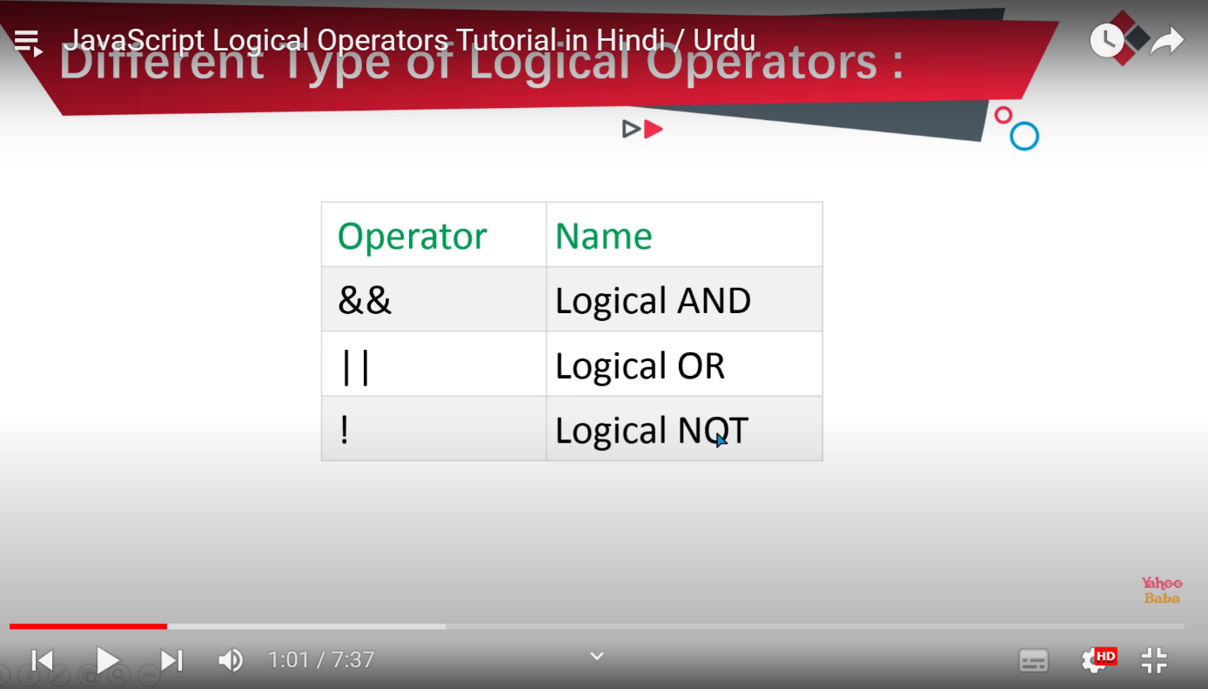

* && logical ANd

if(condition 1 && condition 2)//dono condition true hona lazmi hota ha//

{

* || logical oR

if (condition 1|| condition 2 ) //is ma 1 ak condition true hona zaroore hota ha//

{

}

* ! logical not

if !(condition) //is ma agr condition true ho ge to false btay ga or agrr false ho to true btayy ga//

if (!a>=20);//ya ulta btay ga agr true ho to false or agr false ho to true//

if else statement

if condi false

true statement runs;

if (conditon /true){

statement run

}

else{

statment does not run

}

if else if stament

if (condition 1 ){

}else if (condition2){

}else{

}

Ternary operators

(condiotion)? true statement: false statment

var x=15;

var z;

// b ="value is" +(a==100? "true" :"false");

(x>10)? z="true":z="false";

document .write(z);

2nd example

Var a =100;

Var b;

(a ==100)? B=”true”:b=”false”

Document.write(b);

switch statement

switch (expression){

case condition 1: statment(s)

break;

case condition 2:statment(s)

break;

case condition 3: statment(s)

break;

default: statment(s)

}

//script>

switch(day){

case 0;

d.wr("today is ");

break;

case 1;

d.wr("today is ");

break;

case 2;

d.wr("today is ");

break;

case 3;

d.wr("today is ");

break;

case 4;

d.wr("today is ");

break;

case 5;

d.wr("today is ");

break;

case 6;

d.wr("today is ");

break;

default: "enter valid number"

javascript Alert box

<script>

alert("hello message")//is sa message display hota ha//

</script>

var a=10;

var b=20;

if(a>b){

alert("A is greater");

}else{

alert ("b is greater");

}

concatination //is sa ak chez ma dosre chez add kr sakta ha//

( "value of A:"+a);

java script confirm box:

<script>

confirm("do you like our website?");

</script>

/2

<script>

var a=confirm("do you like our website?"):

alert(a); /// is sa true or false ataa ha ok or cancel button ma//

</script>

java script prompt box

//prompt sa confirm box atta ha //

<script>

var per=prompt("enter your percentage: ");

if(per>=80 && per <=100){

document.write("you percenteage in execellent");

}else if(per>=60 && per <80){

document.write("you percenteage in very good");

}else if(per>=40 && per <60){

document.write("you percenteage in good");

}

else if(per>=30 && per <40){

document.write("you percenteage is bad ");

}else if(per<33){

document.write("you are fail");

}else{

document.write("please enter valid percentage");

}

javascript function

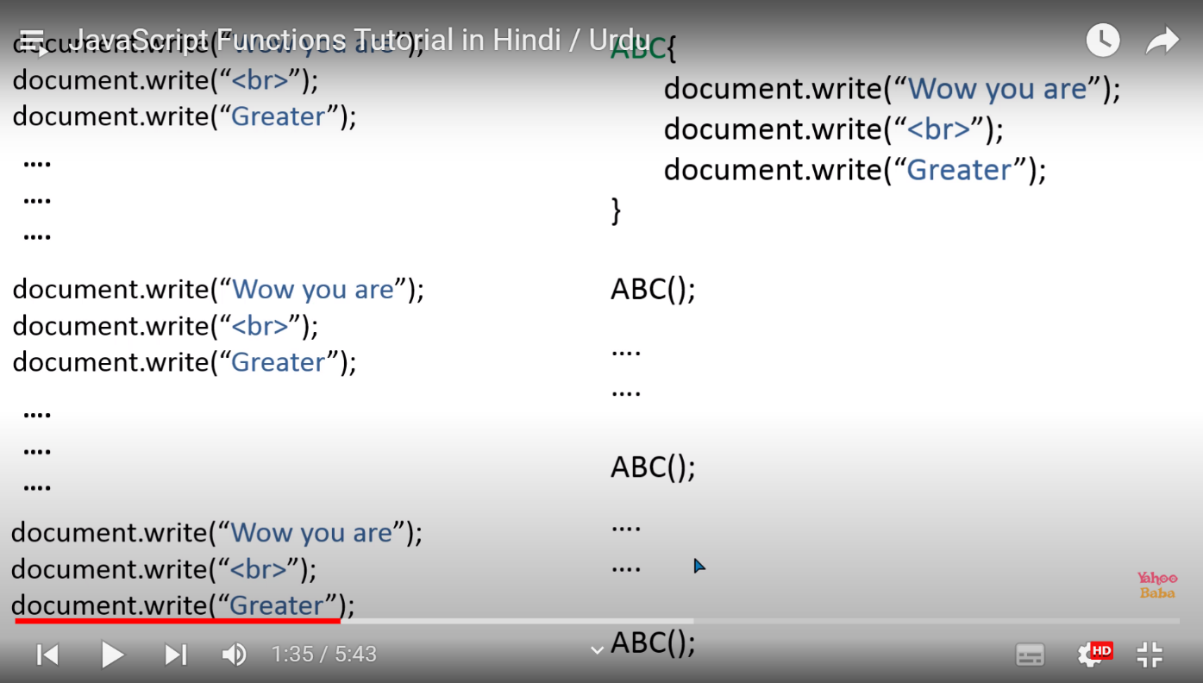

function functionName(){///function defination//

statement

}

functionName():// function calling ;

<script>

function hello(){

document.write("hello everybody"):

}

hello():

</script>

javascript function with parameter

function functionName(parameter 1, parameter 2){

}

// //

function sum (a,b){

document .write(a+b);

}

sum(10,20);

....

....

sum(30,40);

function with return value

function functionName(parameter 1, parameter 2){

statemens

return value

}

// //

<script>

function sum(math,eng,sc){

var s=math+ eng+sc;

return s;

}

function percentage(Tt){

var per=tt/300*100;

document.write(Per);

}

var total=sum(90,30 ,30);

percentage (total);

</script>

Global&local variable

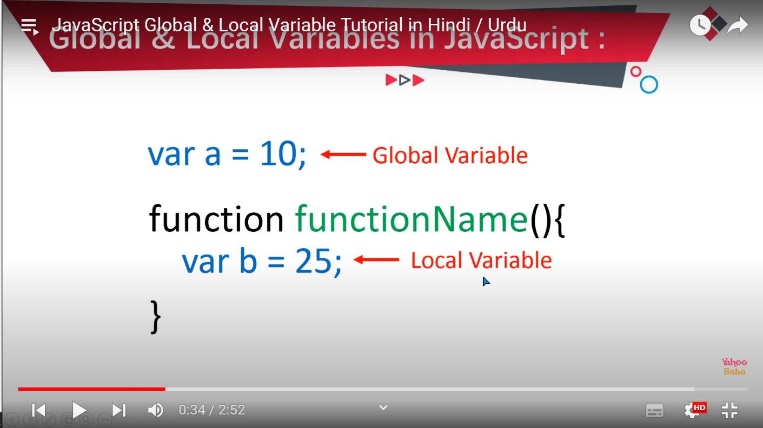

Global variable function ka andr or bahir be kam karta ha

Local function ka under kam karta ha

javascript events

mouse events keyboard events

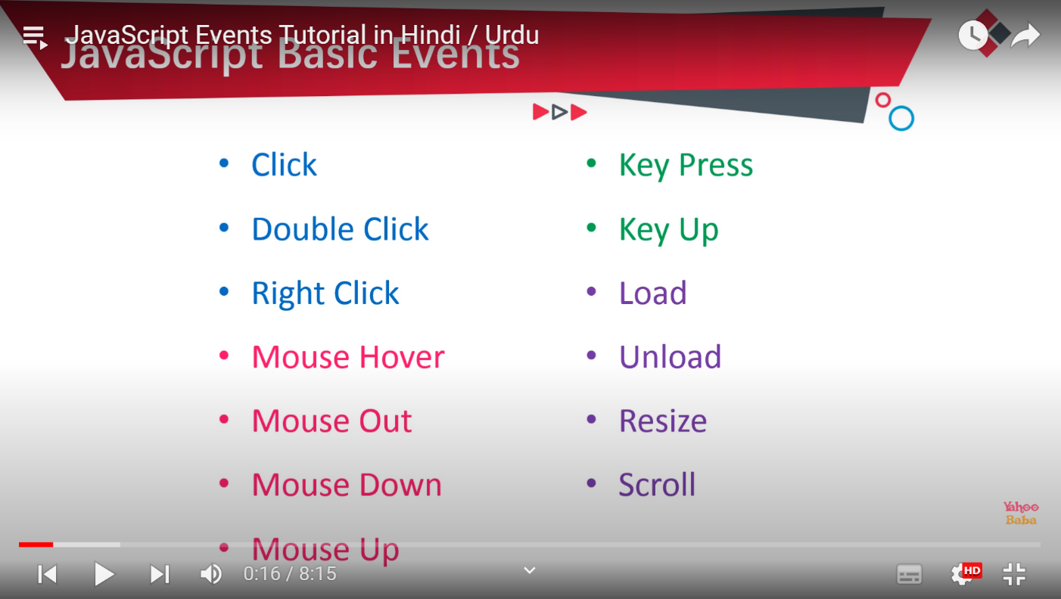

* click(onclick) key press(onKeypress)///ya body tag ma kam karta ha ya form ma
* double click(ondblclick) key up(onkeyup)
* right click(oncontextmenu) load(onload)
* mouse hover(onmouseenter) unload(onunload)
* mouse out(onmouseout) resize(onresize)
* mousedown(onmousedown) scroll(onscroll)
* mouse up(onmouseup)
* 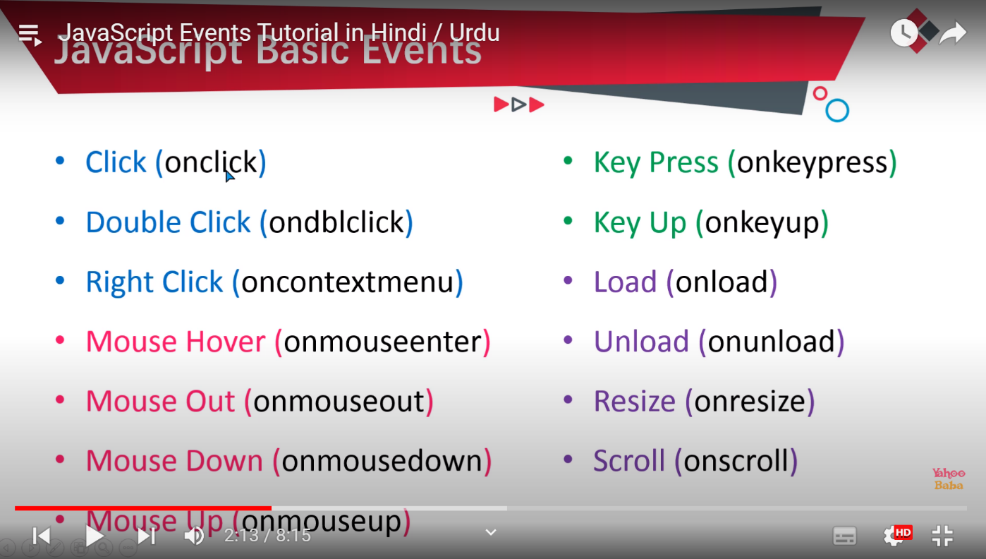

onClick

<script>

function hello(){

document.write("Hello Everyone");

}

</script>

<body>

<button onClick="hello()">click me</button>

</body>

while loop

divided into 3 parts

* initialization
* condition false

true

* increment/decrement

type of loops in javascript

* while loop

for increment

( var a =1;

while(a<=10){

document.write("hello world <br>");

a=a+1;// increment

for decrement

var a=10;

document.write("ul");

while(a>=1){

document.write("<li>" + a+ "hello world<br>")

a=a-1; //for decrement

}

document.write("/ul");

* do/while loop

// is ma phle condition nai check hoti 2nd time condtion check hoti ha

var a=1;

do{

document .write(a + "yahoo baba<br>");

a=a+1//ya a++ istamal kr sakta ha;

}while(a<=10)

* for loop

for (var a=1;a<=10;a++){  
document.write("hello<br>")

}

* for/in loop(objects)
* for each(array)

javacript break &continue statement

continue sa lafz change ho jata ha/ 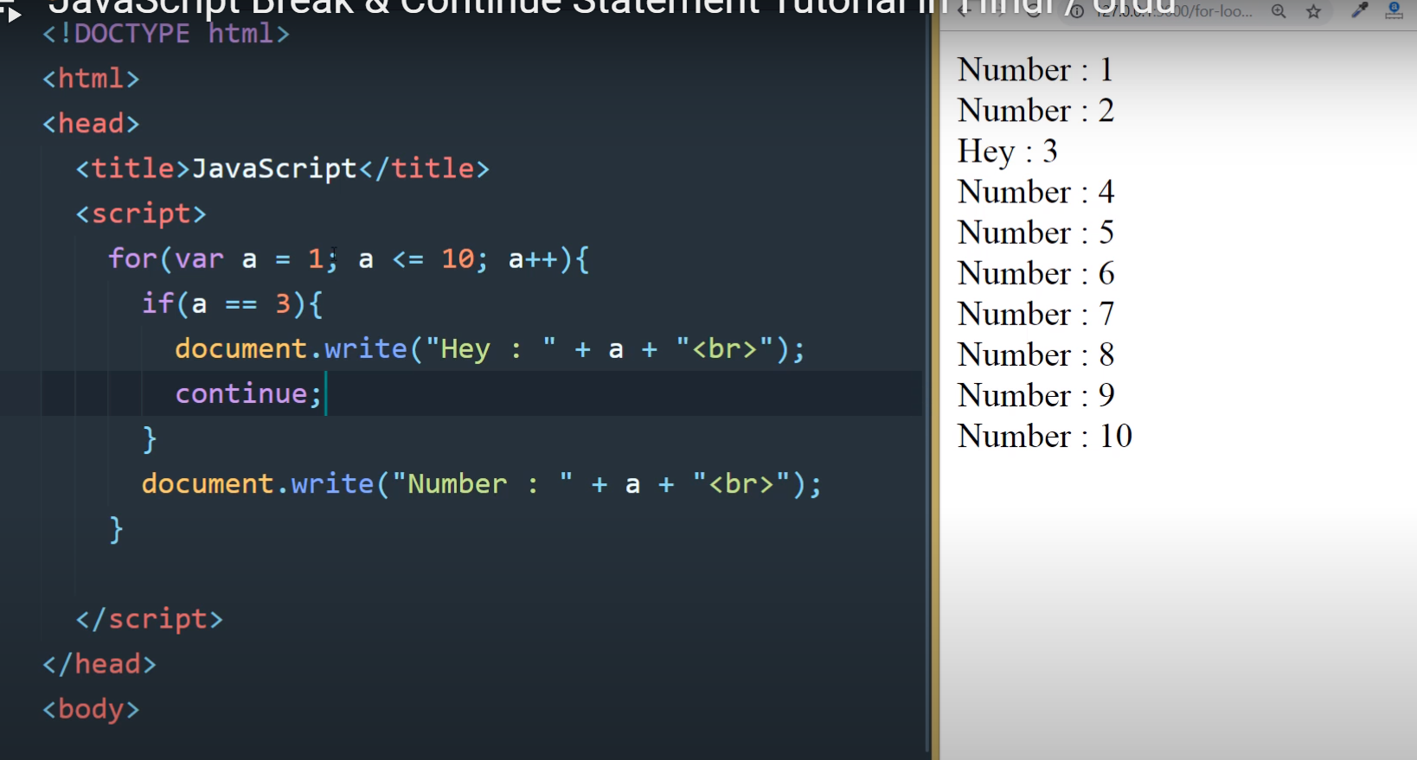

<script>

for(var a=1;a<=10;a++){  
if (a==3){

document.write("hey: "+a+ "<br>");

continue/break;

}

document.write("number: "+a+"<br>");

}

</script>

Break statement

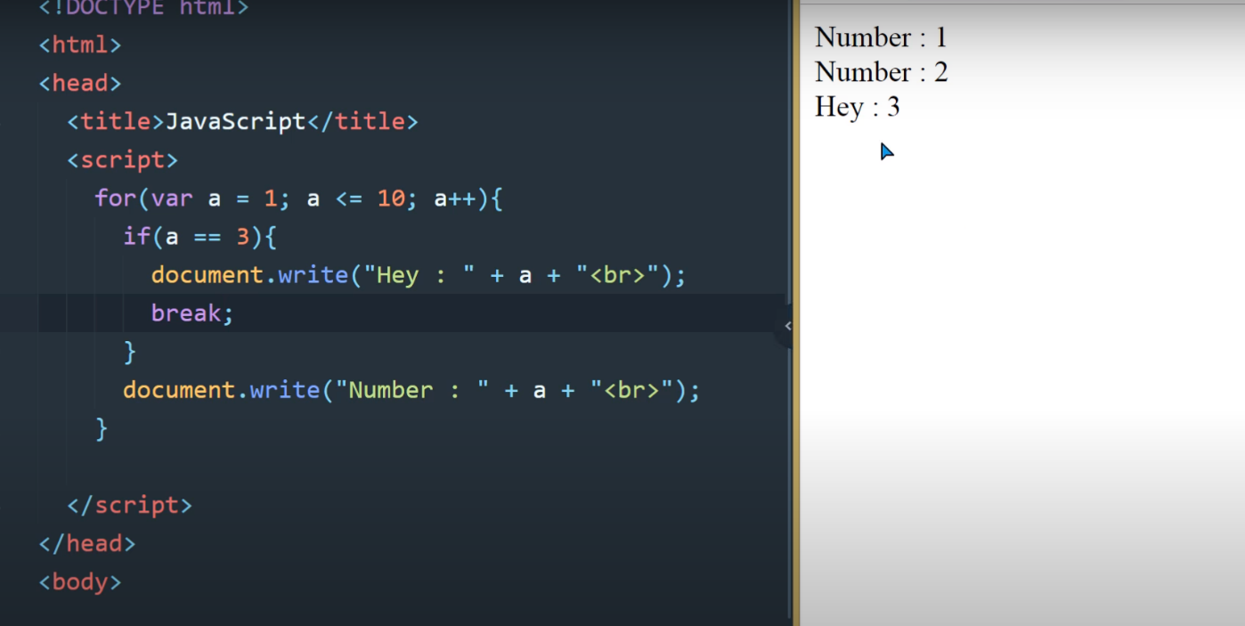

javascript even &odd numbers

even number wo hota ha jo 2 sa divide ho

odd num/3

<script>

for(var a=1;a<=10;a++){

if(a%2==0)

//(a%2!=0) {

document.write(a+"<br>"):

}

}

javascript nestedloop

for (var a=1; a<=10; a++){ //outer loop for rows

for(var b=1;b<=10;b++){ //inner loop// for column

statement

}

}

<script>

for(var a=1; a<=100; a=a+10){  
for(var b=a;b<a+10; b++){

document.write(b + " ");

}

document.write("br");

}

</script

Example)

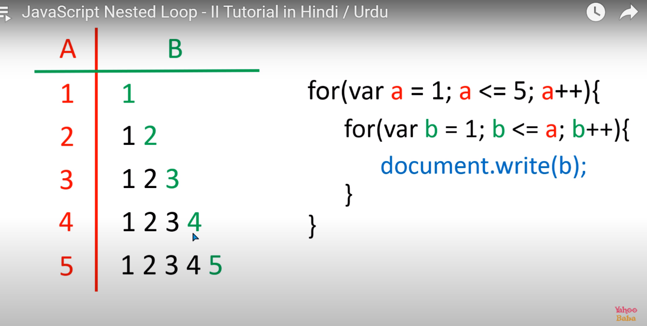

1

1 2

1 2 3

1 2 3 4

1 2 3 4 5

<script>

for (var a=1; a<=5; a++){

for (varb=1;b<=a;b++){

document.write(b);

}

}

</script>

Example

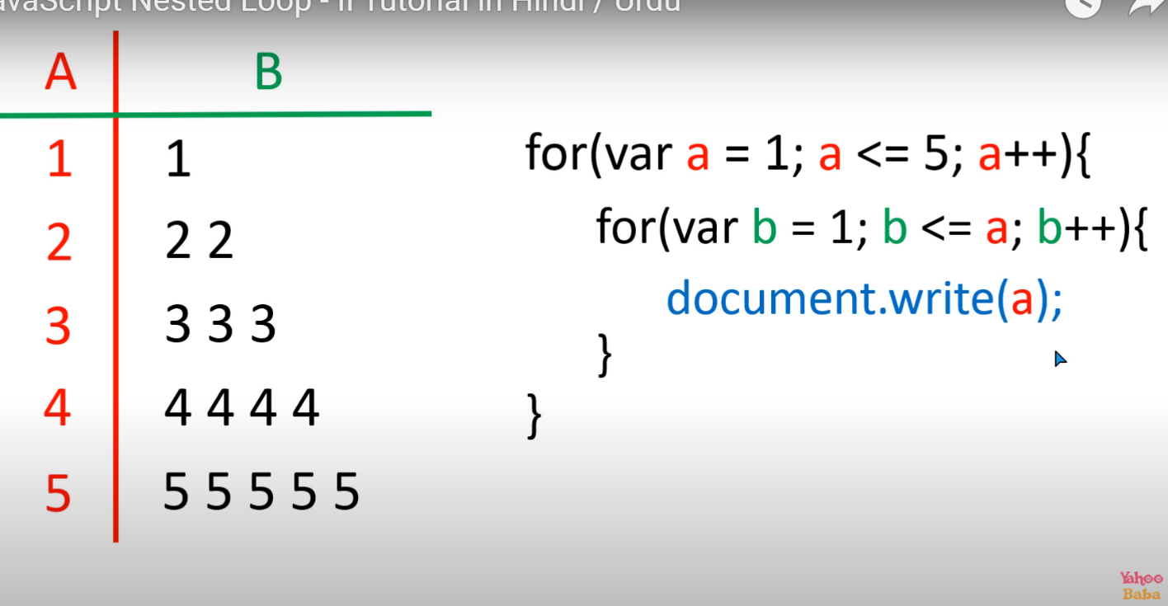

1

2 2

3 3 3

4 4 4 4

5 5 5 5 5

for(var a=1; a<=5; a++){

for (var b=1;b<=a; b++){

document .write(a);

}

}

Example

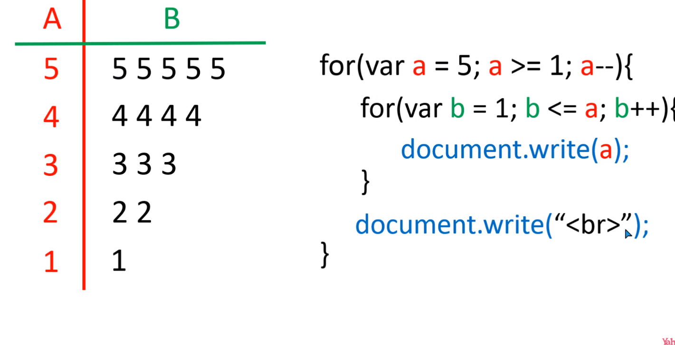

5 5 5 5 5

4 4 4 4

3 3 3

2 2

1

for(var a=5;a>=1;a--){

for(var b=1;b<=a;b++){

}

}

Example

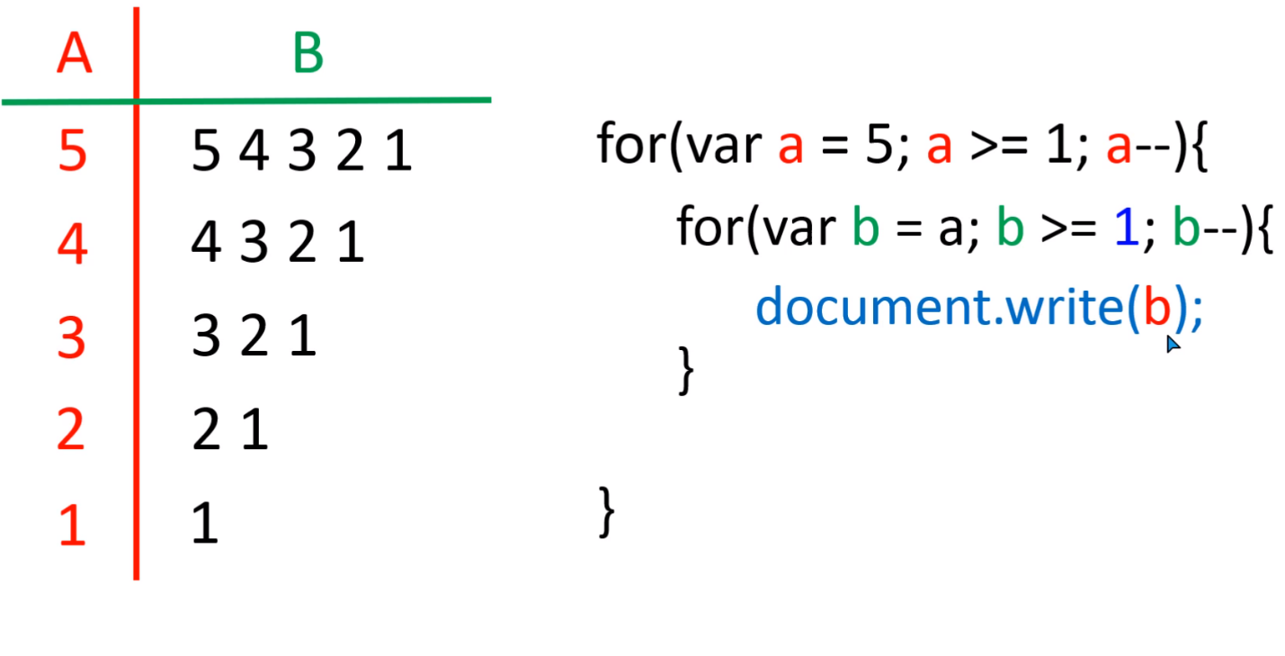

5 4 3 2 1

4 3 2 1

3 2 1

2 1

1

for (var a=5; a>1;a--){

for(var b=a;b>=1;b--){

document.write(b);

}

document.write("<br>");

}

javascript Array

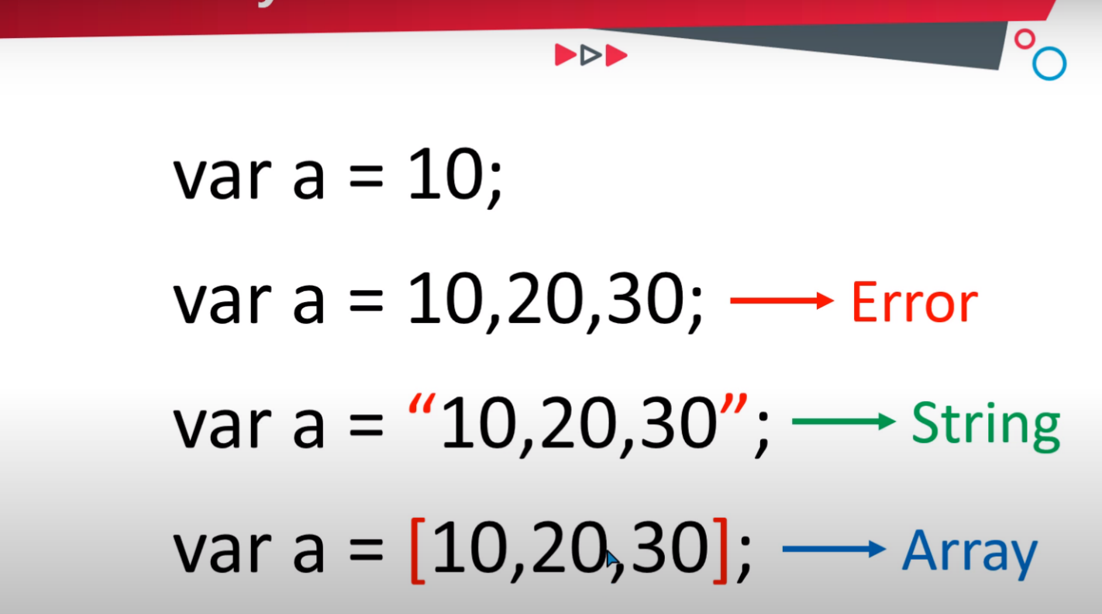

var a=10;

var a=10,21,30; error

var a="10,20,30"; string

var a=[10 ,20,30]; array

<script>

var array=[10,20,30,40,50];

for (var a=0;a<=4;a++){

document.write(array[a]);

}

</script>

sum =sum+array[a];

Another way to create a new array

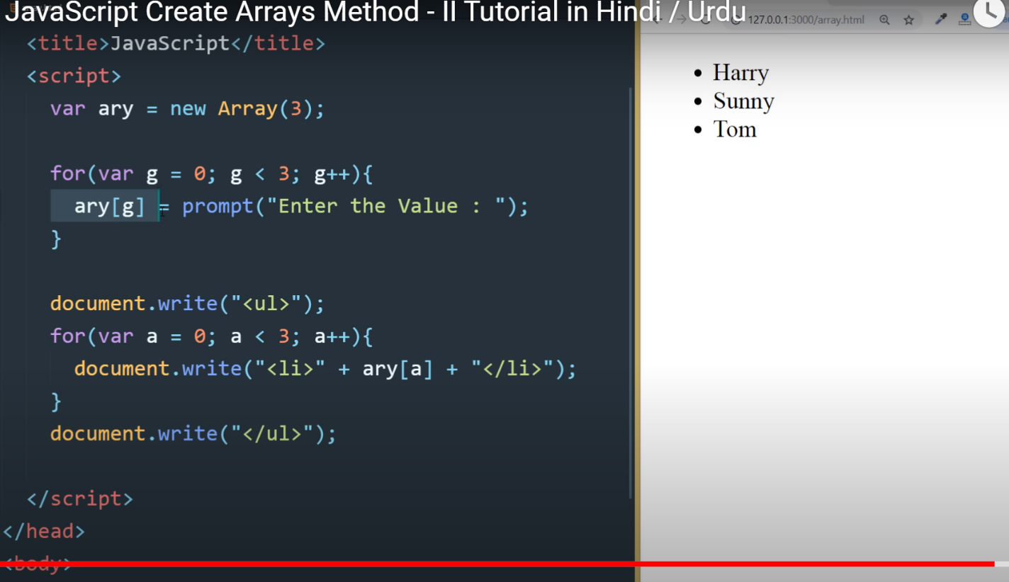

Iss sa array ma value store hoti ha

 <script>

var ary=new Array(5);

for(var g=0; g<5; g++){

    ary[g]=prompt("enter the value:");

}

// document.write("<ul>");

    for(var a=0;a<5;a++){

        document.write( ary[a]+"<br>a" );

    }

    // document.write("</ul>");

            </script>

var ary =new array();

ary[0]=10;

ary[1]="anjum";

ary[3]="true";

ary[4]="null";

//

for(var g=0;g<3;g++){  
ary[g]=prompt("enter the value: ");

document.write("<ul>");

for(var a=0;a<3;a++){

document.write("<LI>"+ "</li>");

}

document.write("</ul>");

another example

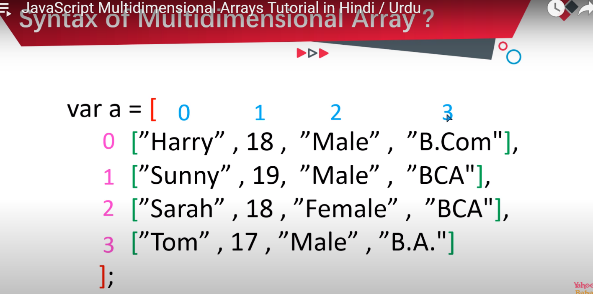

<script type="text/javascript">

var array=[

["harry",18,"male","b.com"],

["sunny",20,"male","bsc"],

["sarah",18,"male","bca"],

["tom",17,"male","b.a"]

];

for(var a=0;a< 4;a++){

for(var b=0;b<4;b++){

documemt.write(arr[a][b]+ " ");

}

documemt.write("<br>")

}

</script>

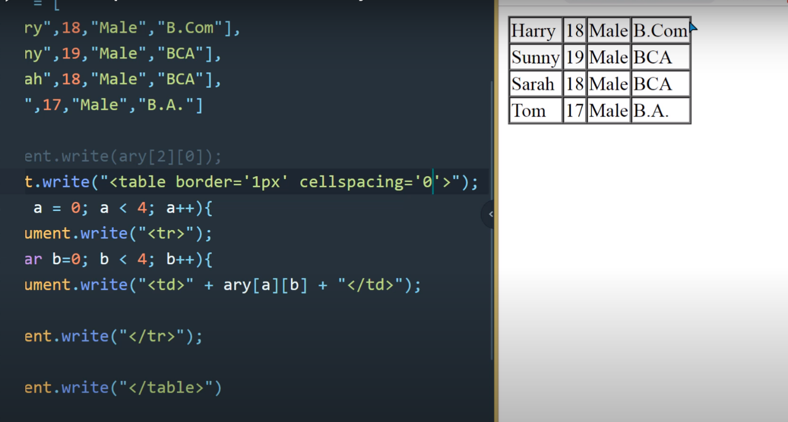

documen.write(ary.length);// is sa lenght pata chalti ha string ke

array modified and delete

* example for modified array

var a=["harry", 18,"bca"];

var a[1]=19;

* example for delete array

var a=["harry", 18, "bca"];

delete a[1]

[bc230400567aas@vu.edu.pk](mailto:bc230400567aas@vu.edu.pk)

javascript Array methods

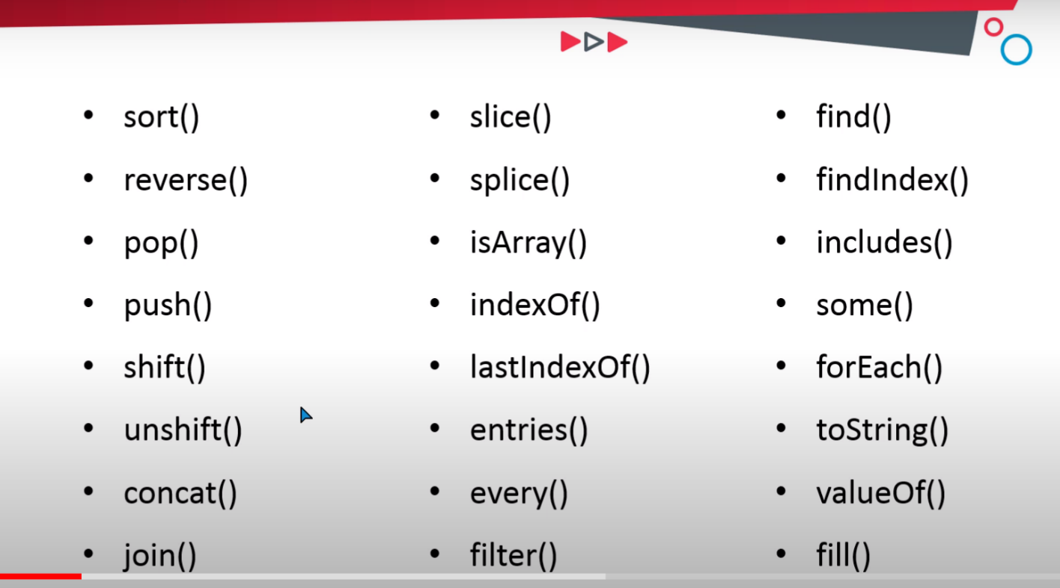

* sort(){ //is sa lafz sedha ho jata ha abc ma (e.g bca sa abc)

<Script>

var a=["sanjay" ,"Aman" ,"Rehan","karan"];

a.sort();

document.write(a+"<br>);

</script>

* reverse() // is sa har chez reverse ho jati ha e.g(abc sa cba )

<Script>

var a=["sanjay" ,"Aman" ,"Rehan","karan"];

a.reverse();

document.write(a+"<br>);

</script>

* pop() // ya last wale lafz ko delete kr deta ha

(karan ko delete kr da ga)//

<Script>

var a=["sanjay" ,"Aman" ,"Rehan","karan"];

a.pop();

document.write(a+"<br>);

</script>

* push() // is sa last ma lafz add ho jata ha(karan sa aga add ho jata ha)

<Script>

var a=["sanjay" ,"Aman" ,"Rehan","karan"];

a.push(“salman”);

document.write(a+"<br>);

</script>

* shift()// is sa phle value delete ho jati ha(sanjay delete ho gay ga)

<Script>

var a=["sanjay" ,"Aman" ,"Rehan","karan"];

a.shift();

document.write(a+"<br>);

</script>

* unshift()// is sa phle value add ho ge(rahul aga aa jay ga)

<Script>

var a=["sanjay" ,"Aman" ,"Rehan","karan"];

a.unShift("rahul");

document.write(a+"<br>);

</script>

* concat() /// ya 2 array ko apas ma jorta ha//

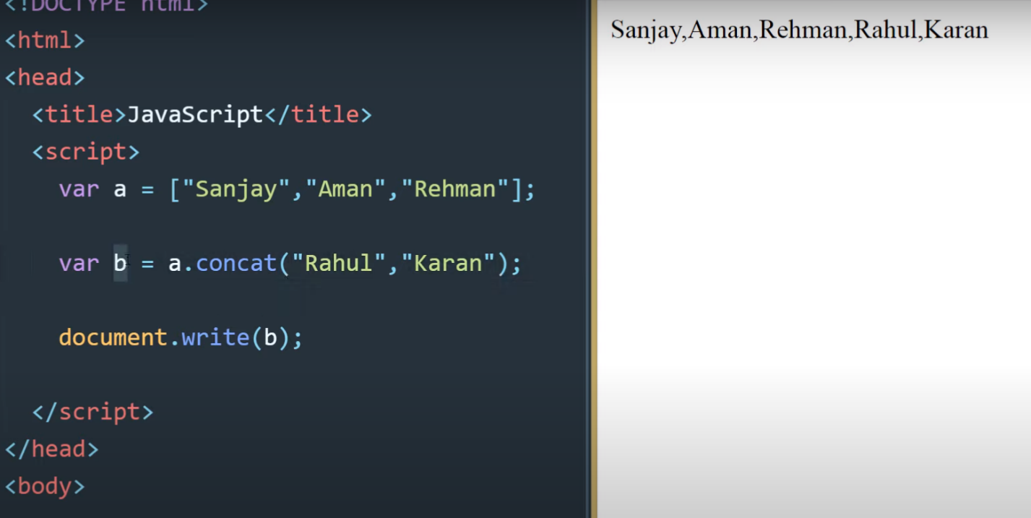

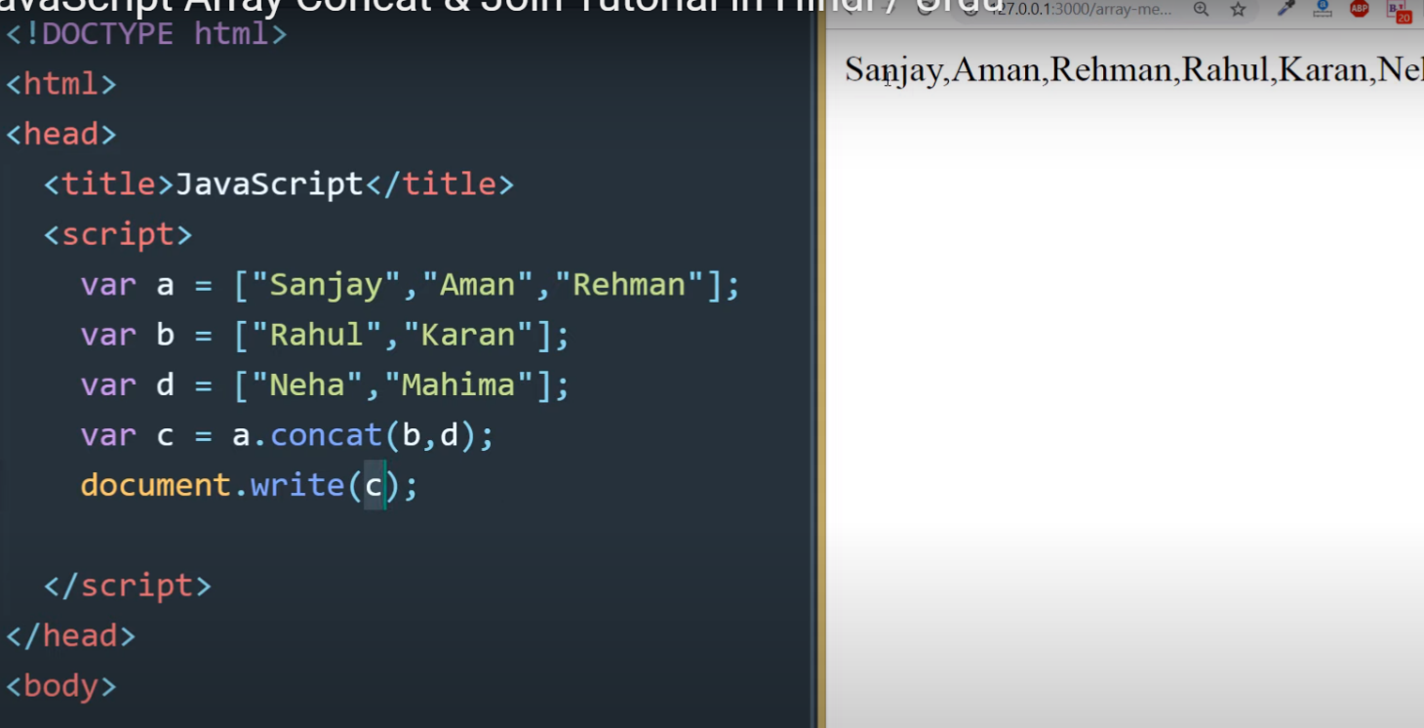

<Script>

var a=["sanjay" ,"Aman" ,"Rehan","karan"];

var b=["karan","rahul"];

a.concat();

// var c= a.concat(b);

document.write(a+"<br>);

</script>

* join()//ya sub ko ak string bna deta ha//

<Script>

var a=["sanjay" ,"Aman" ,"Rehan","karan"];

a.join("");

document.write(a+"<br>);

</script>

* slice() /// is sa first or end wala skip ho jata ha//

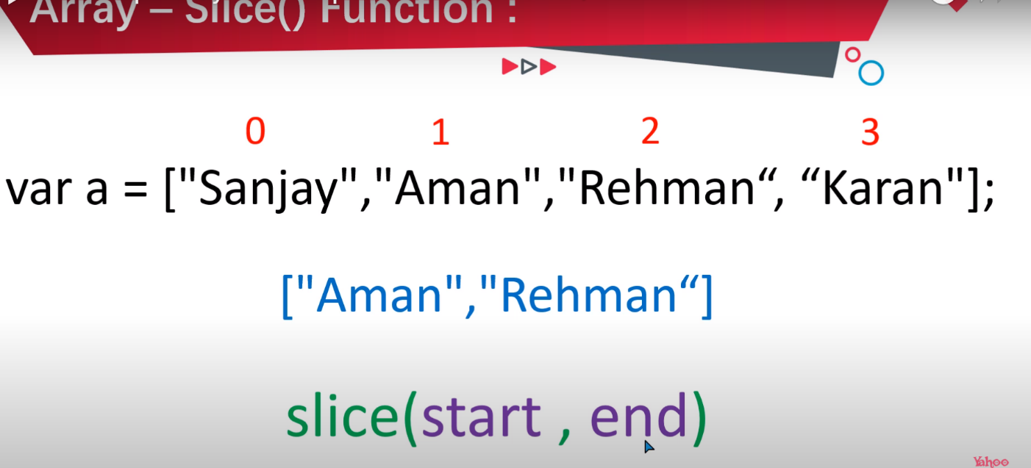

var a=["sanjay" ,"Aman" ,"Rehan","karan"];

a.slice(1, 4);

document.write(a+"<br>);

</script>

* splice() // is ma value hum add kar sakta ha jidr marzi ho//// a.splice(2 mean ka dosra index ma dalna ha 0 mean koi chez delete nai karni //
* 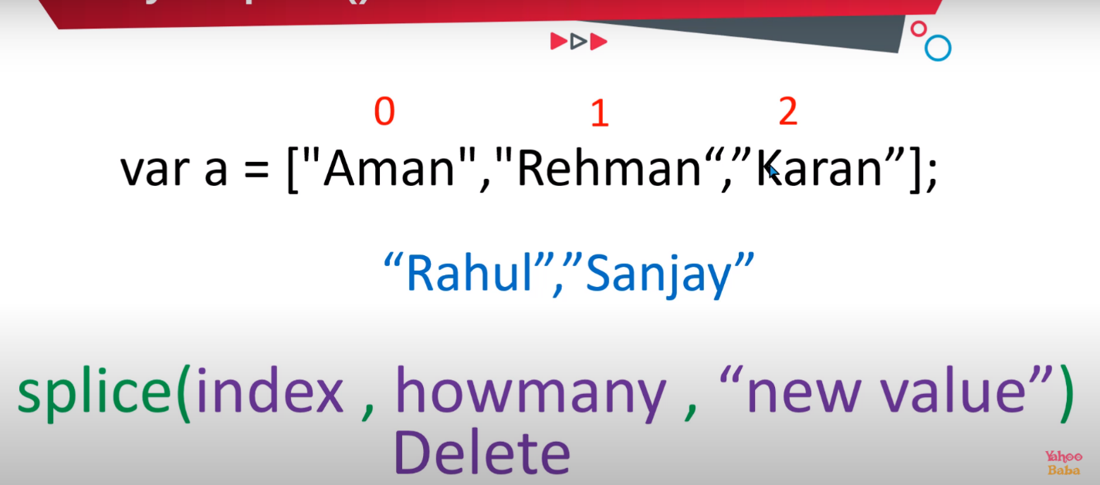

<script>

var a=["sanjay","aman","rehman","rahul"];

document.write(a+"<br><br>");

a.splice(2 ,0,"neha","karan");

docment.write(a+"<br><br>");

</script>

* isArray() // is ma ya hota ha ka varible array ha ya nai // //or array ma english charater ata ha or number orstring ko false kr deta ha ko false kr deta ha//
* 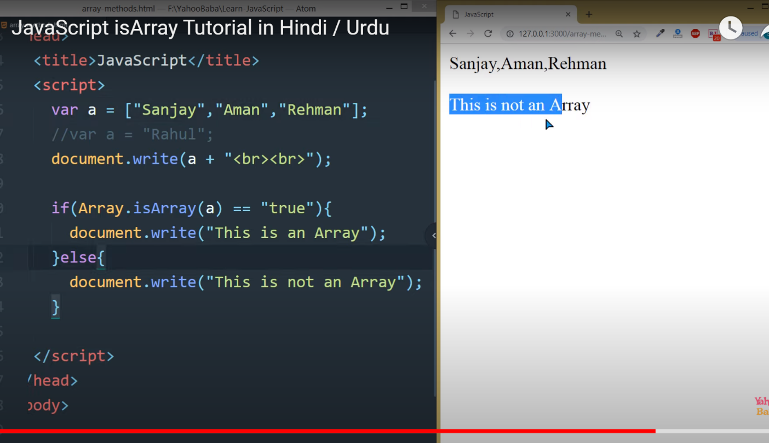

<script>

// var a=["sanjay","aman","rehman"];

var a=20;

document.write(a+"<br><br>");

if (array.isArray(a)){

document.write("this is an array");

}else{

document.write("this is not an array");

}

</script>

* indexOf()// is ma phle item search hota ha fr jidr sa start karna ho //or ya btay ga ka kiss index ma ha 0 yaa 1 ..etc;//agr hum koi or value add kara jo index ma na ho to fr wo -1 display kara ga//ya start sa search karta ha
* 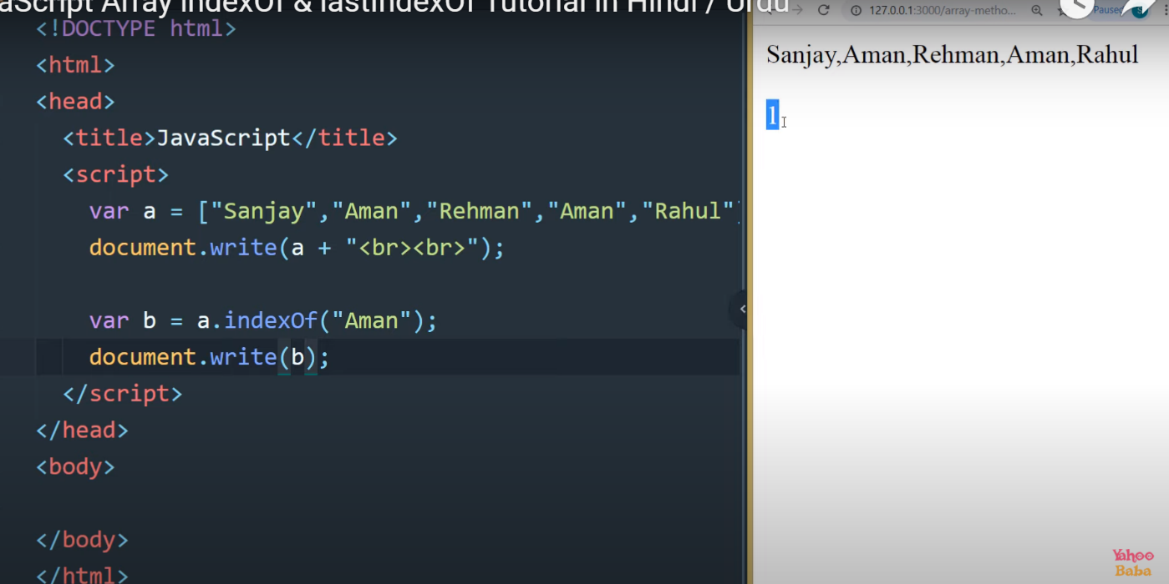

<script>

var a=["sanjay","rehman","aman","rahul"]

document.write(a+"<br><br>");

var b=a.indexof("neha" ,2);

</script>

* lastIndexOf()// indexof or lastindex dono same he kam karta ha pr lastindexof last sa he kam karta ha// ya last sa search karta ha

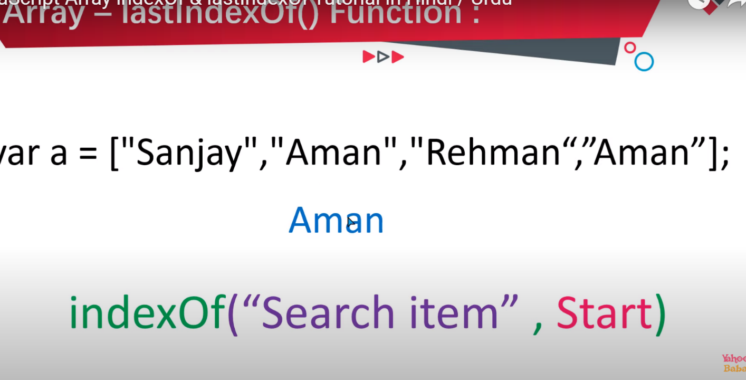

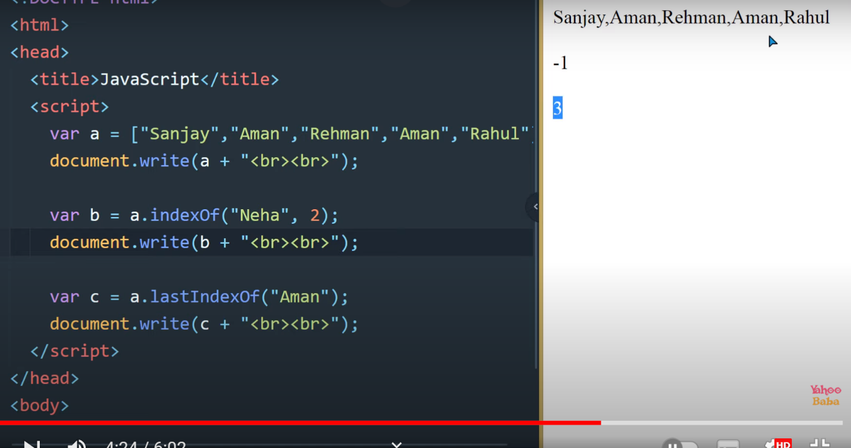

indexoF("sea

<script>

var a=["sanjay","rehman","aman","rahul"]

document.write(a+"<br><br>");

var b=a.lastindexof("neha" ,2);

</script>

* includes()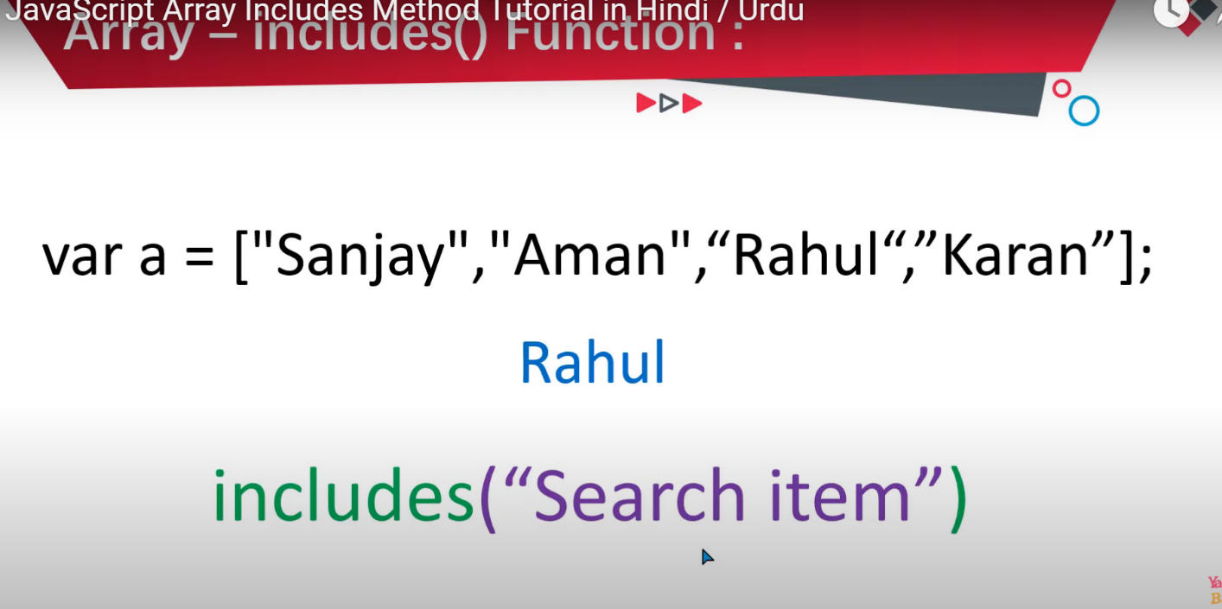
* iss ka anser true/ya false ho ga value ha to true or na ho to false kar deta ha
* include method
* var a=["sanjay","aman","rahul","karan"];
* include ("search item")
* <script>
* var a=["sanjay","rehman","aman","rahul"]
* document.write(a+"<br><br>");
* var b=a.include("Aman");
* document.write (b +"<br><br>");
* </script>

every()// ya be some function ke terha kam karta ha// is ma saree value true na ho to tab tak kam nai karta

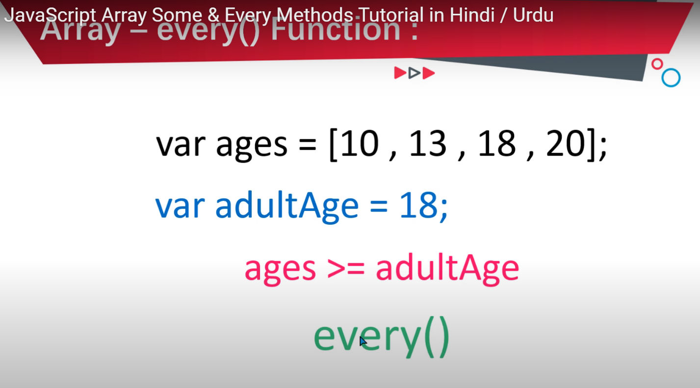

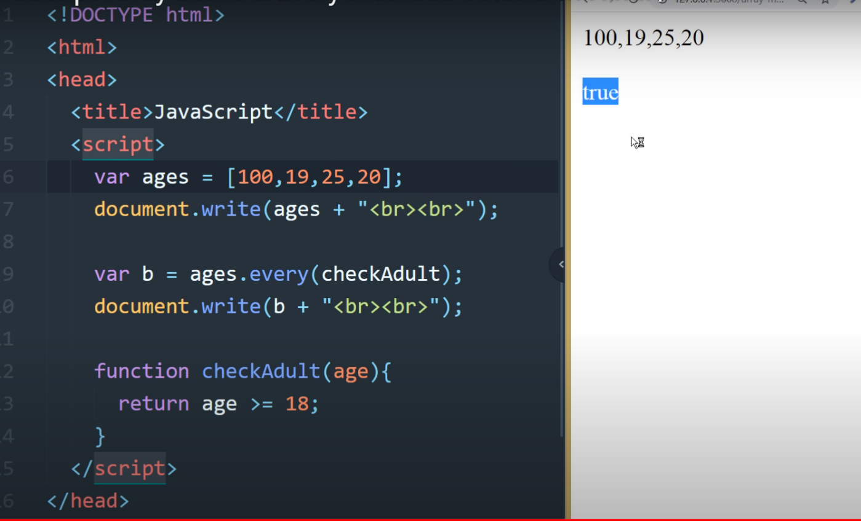

<script>

var ages=[100,19,25,20];

document.write(ages+ "<br><br>");

var b=ages.some(checkAdult);

document.write(b+"<br><br>");

function checkAdult(ages){

return age>=18;

}

</script>

* some()// is ma chez ko check karta ha ya (checkadult ha ya nai)// true or false ma btay ga

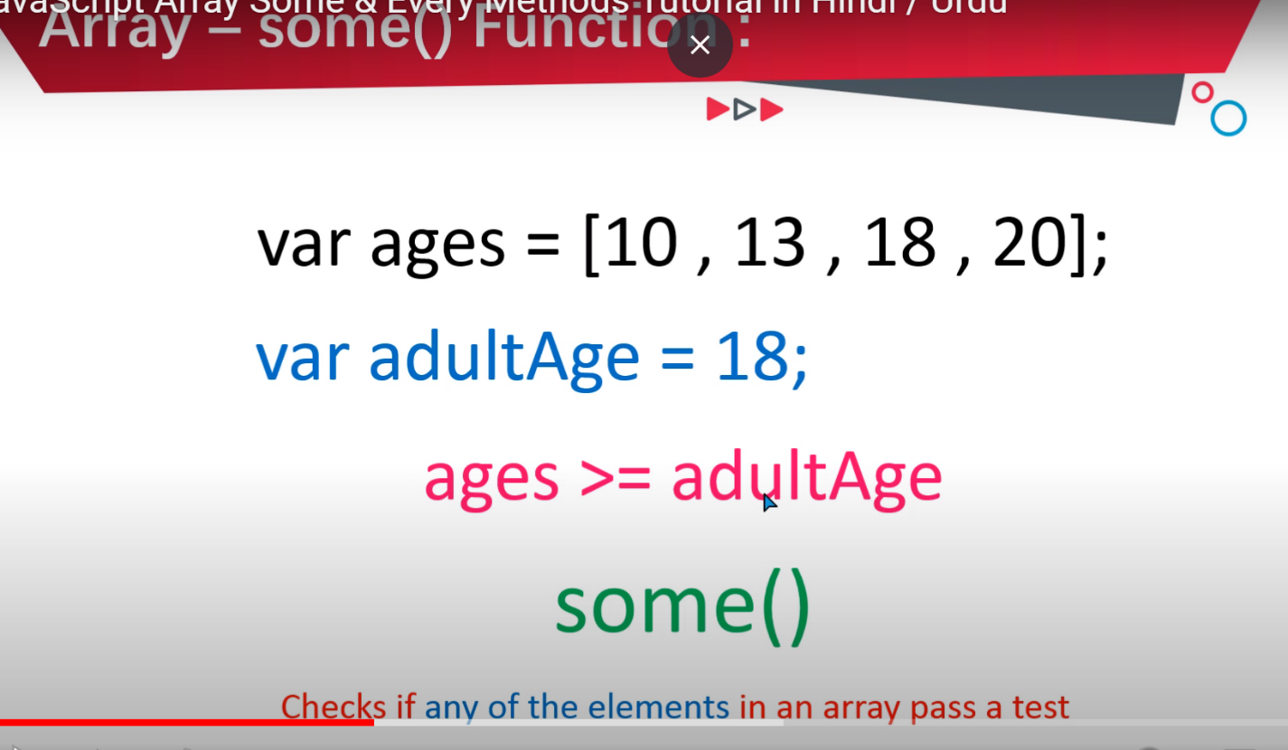

<!-- <script>

    var ages=[10 ,13,18,20];

    document.write(ages +"<br><br>");

    var b=ages.some(checkAdults);

    document.write(b + "<br><br>");

    function checkAdults(age){

        return age >= 18;

    }

</script>  -->

<script>

var ages=[10,13,15,2];

document.write(ages+ "<br><br>");

var b=ages.some(checkAdult);

document.write(b+"<br><br>");

function checkAdult(ages){

return age>=18;

}

</script>

* find()
* //jo value test pass kr la ge uss ke actual value ko return kar da ga //
* 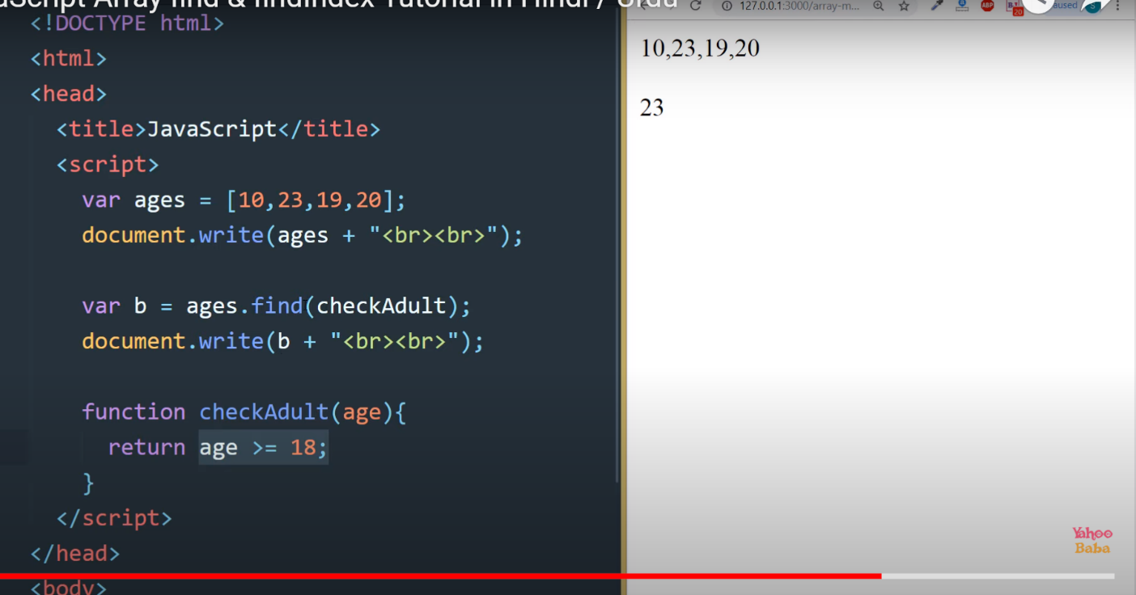
* findIndex()

// ya bilkul index ke terha kam karta ha or iss ma index ka number return hota ha //

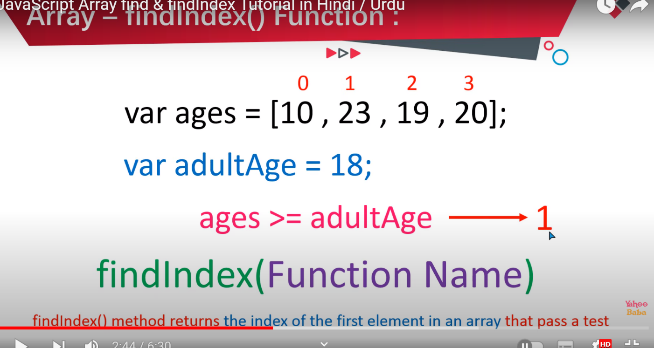

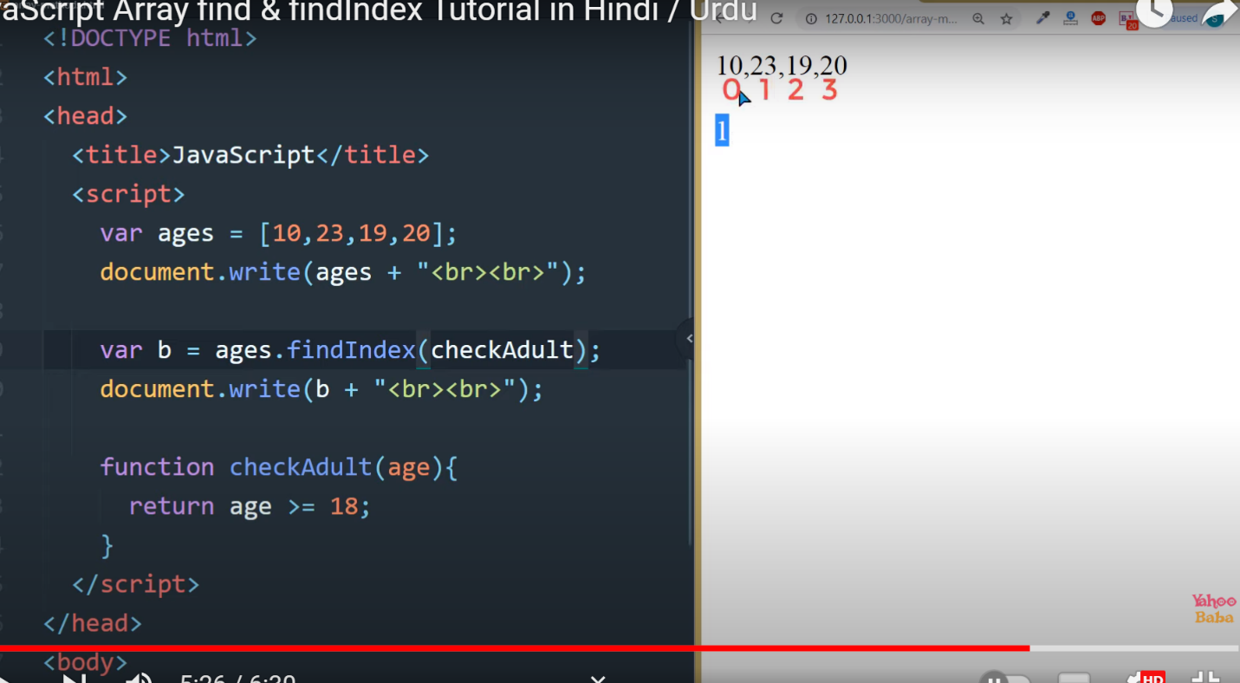

* filter()// ya be find or findindex jasa kam karta ha or is ma jitne value na pass kea hota ha utne value ko return kar deta ha //

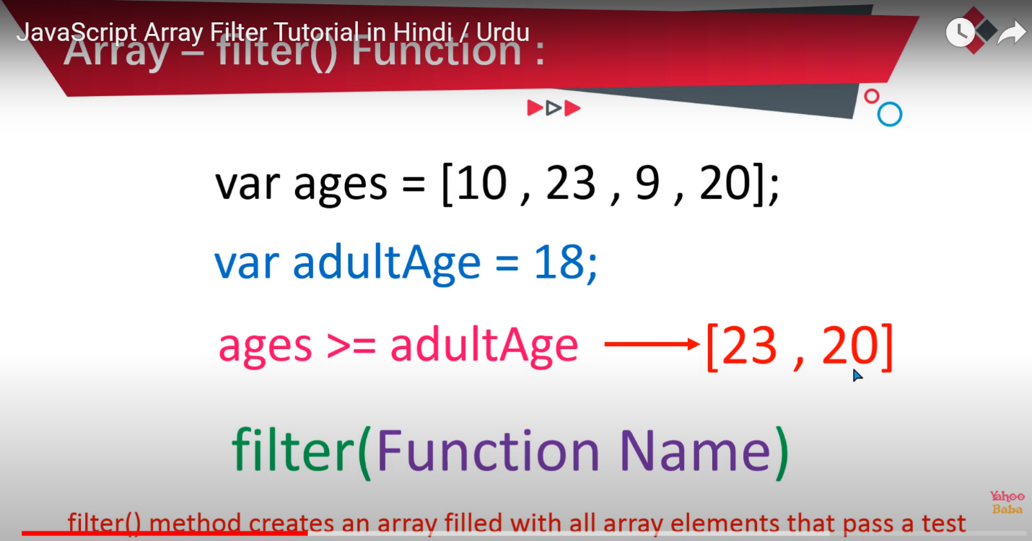

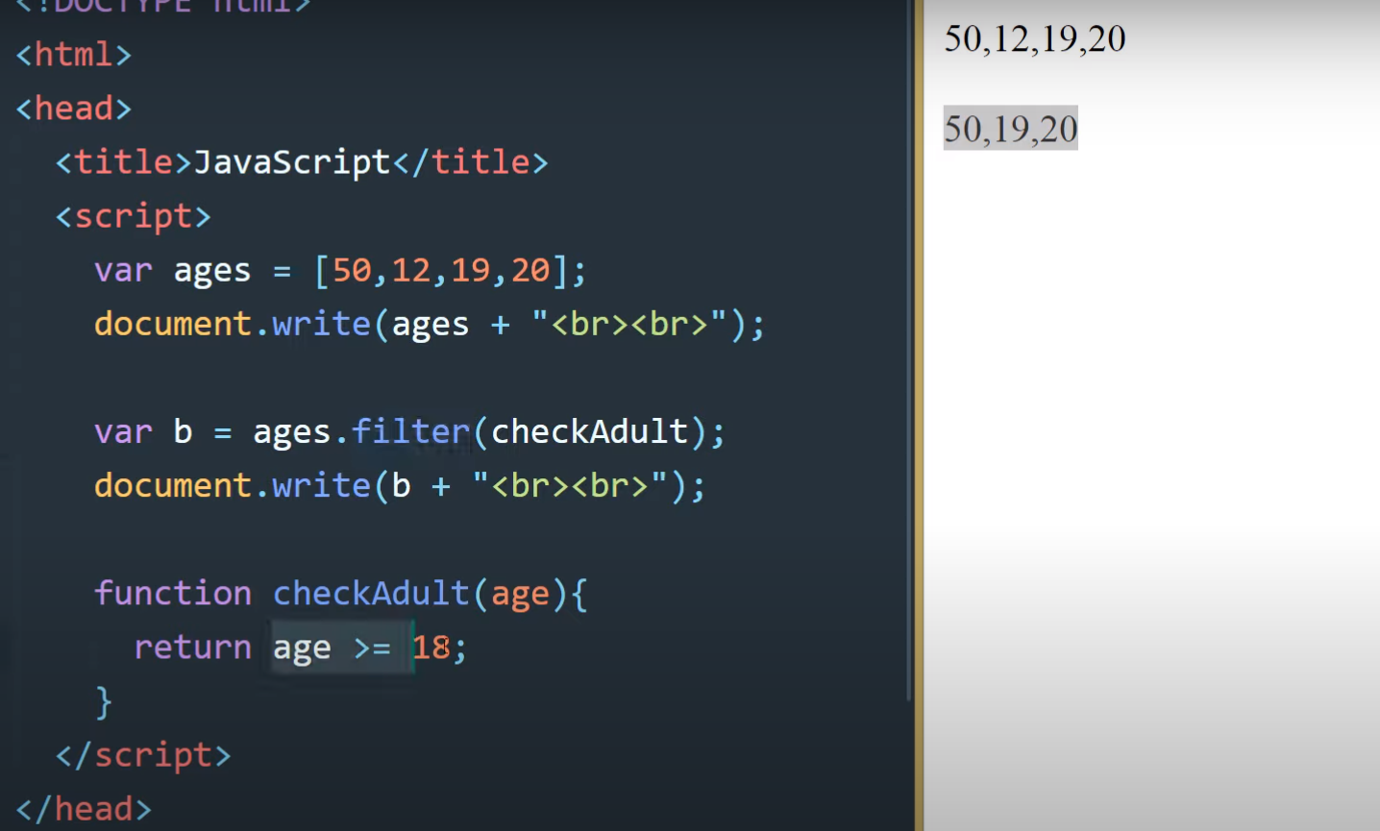

* toString()

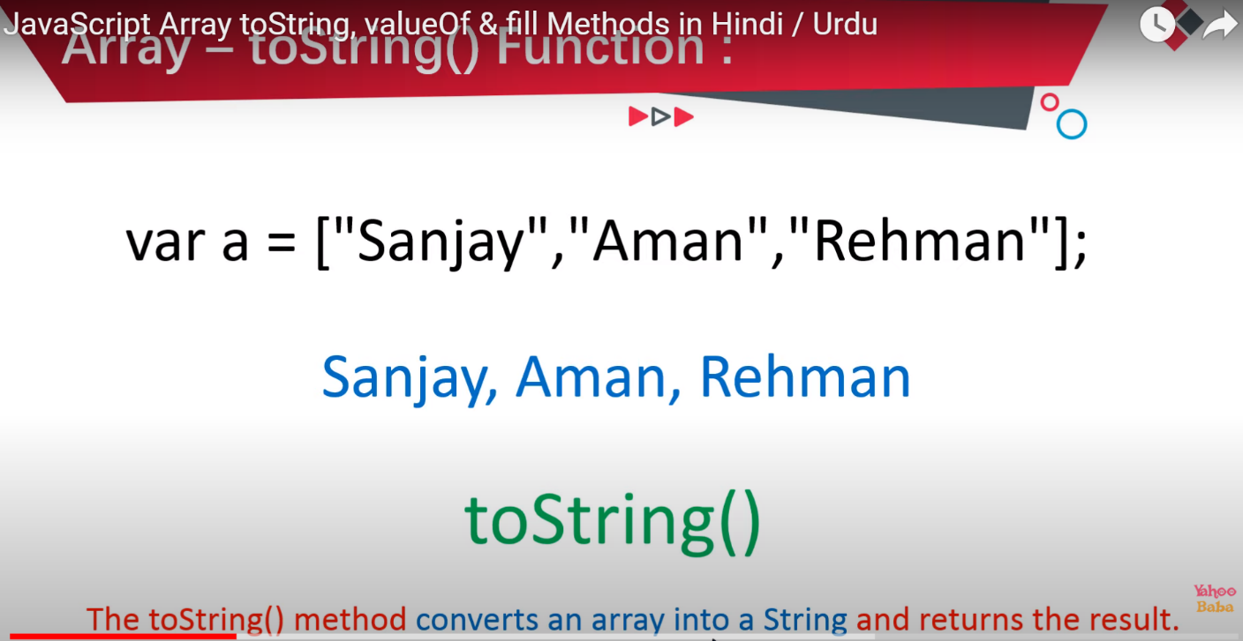

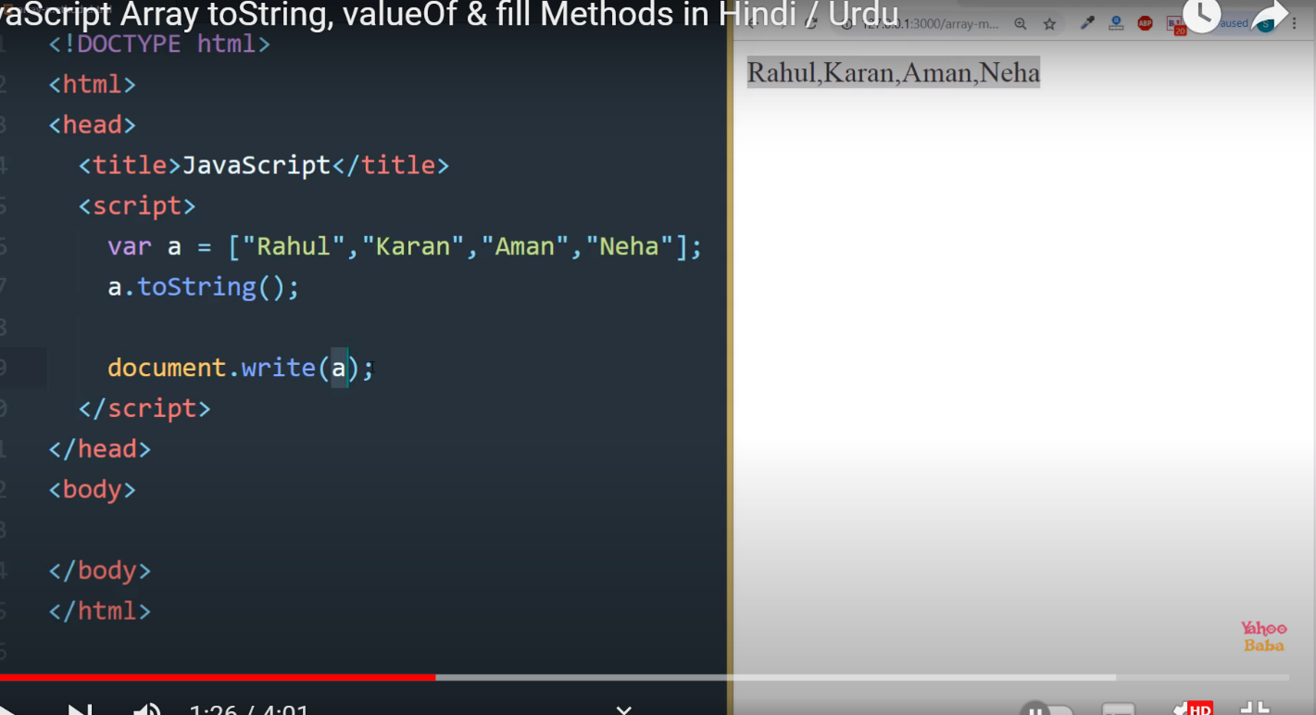

* valueOf()// ya sare value ko print kr detas ha

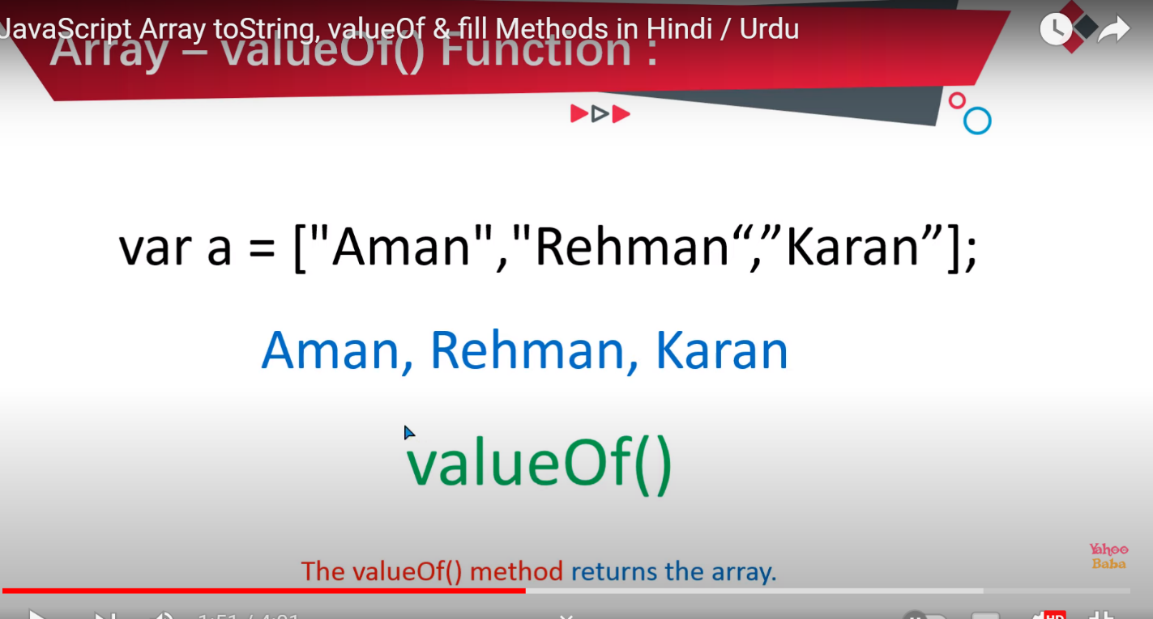

* fill()/// is sa value add hoti ha string ma //

ya khass purpose kali istamla nai hota this is not for special purpose//

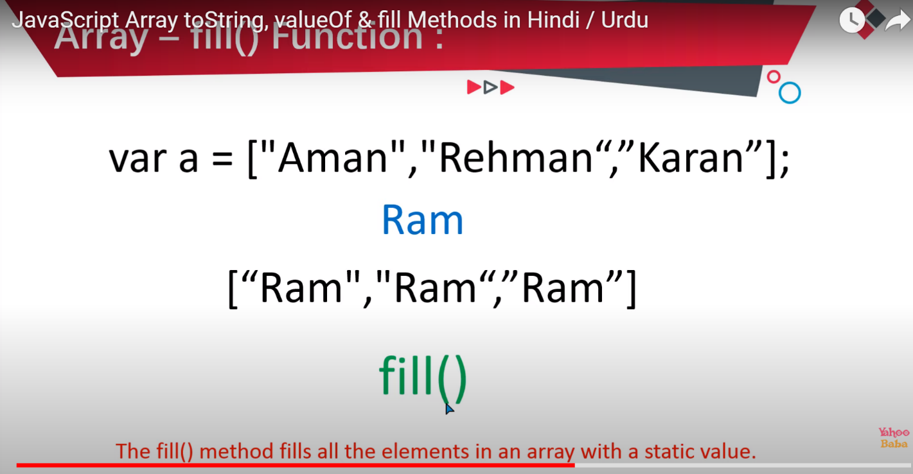

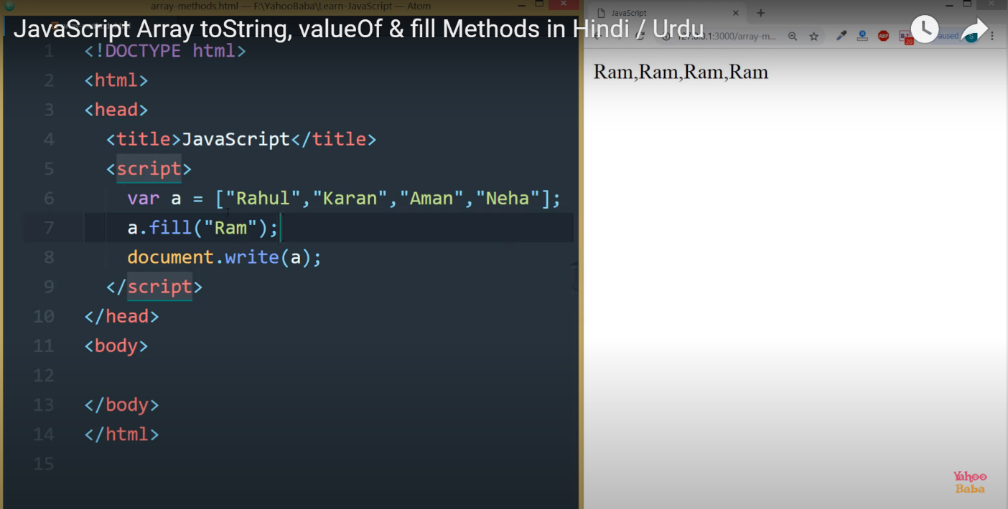

* entries()
* forEach()////

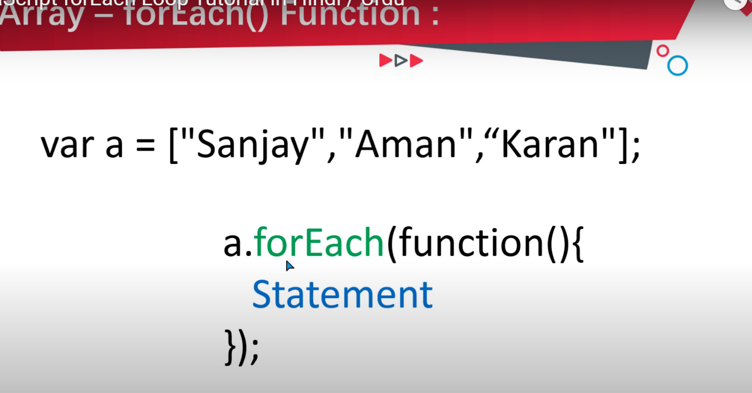

</script>  -->

<!-- <script>

    var a=["rahual","syed","anjum","shah","rahual","syed","anjum","shah" ,"rahual","syed","anjum","shah","rahual","syed","anjum","shah"];

    a .forEach(function(value ,index){

        document.write( index + " : " + value + "<br>");

    })

</script> -->

<!-- 2nd  exmample -->

<!-- <script>

    var a=["rahual","syed","anjum","shah","rahual","syed","anjum","shah"];

    a.forEach(loopz);

    function loopz(value ,index){

        document.write(index + " : "+ value +"<br>");

    }

</script> -->

type of loops in javascript

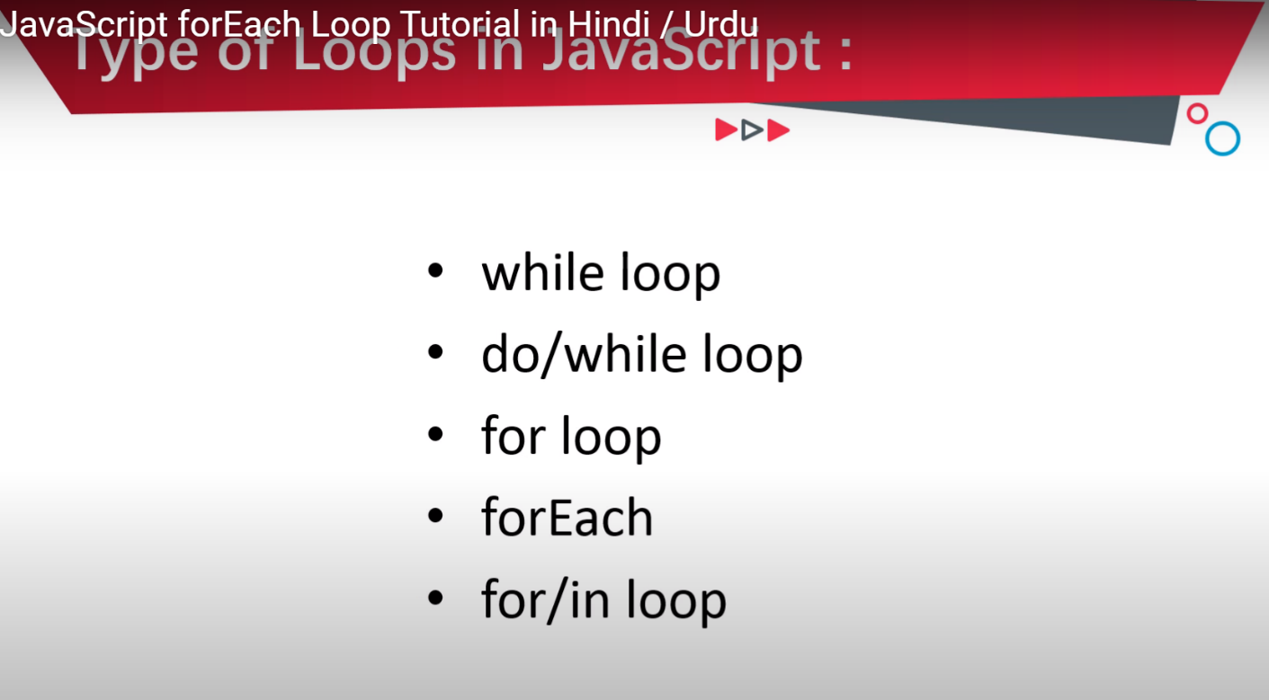

50 turtorial

What is object ?

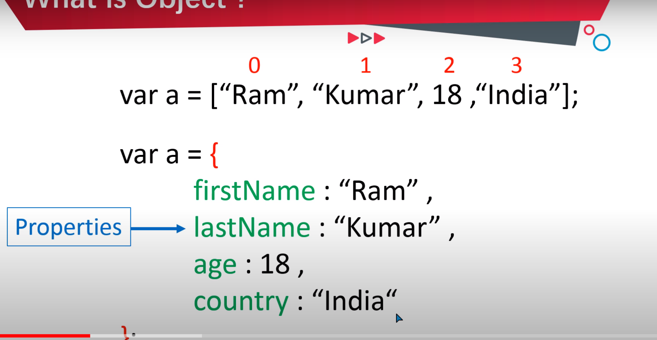

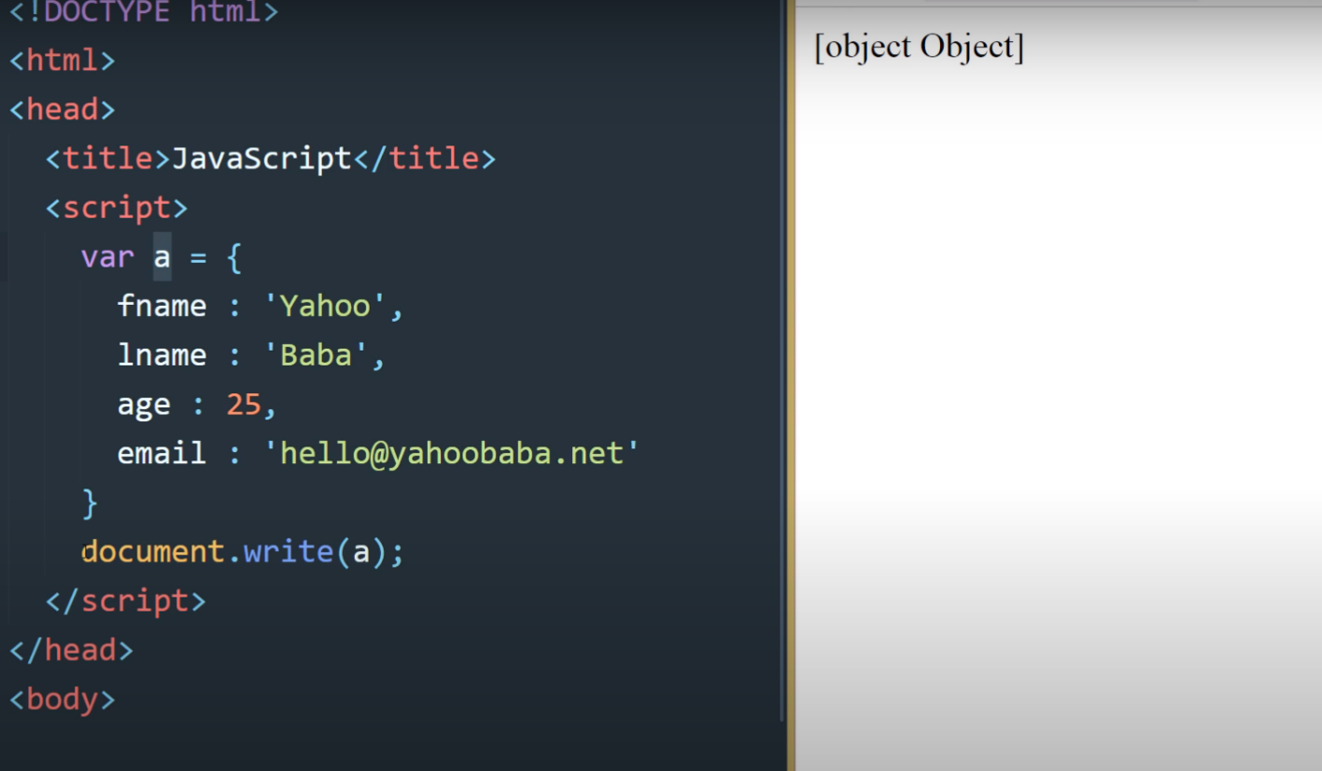

//in console .log ma is ka anser/result iss terha show hota ha //

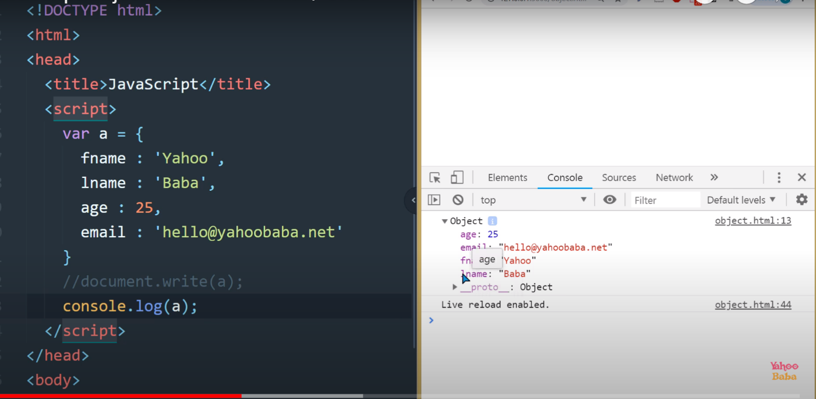

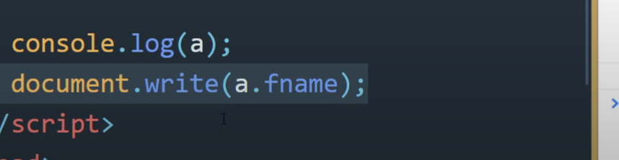

How to make array in objects

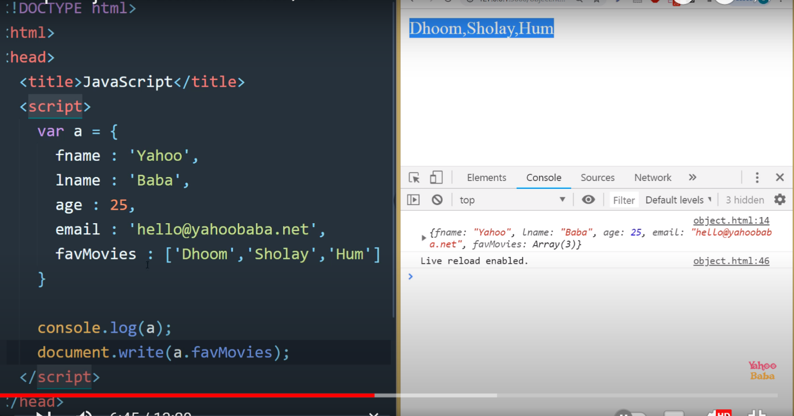

1 value be display krwa sakta ha

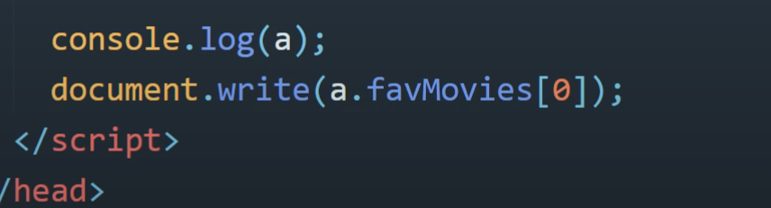

////Or object ma function kasa dalsakta ha ///

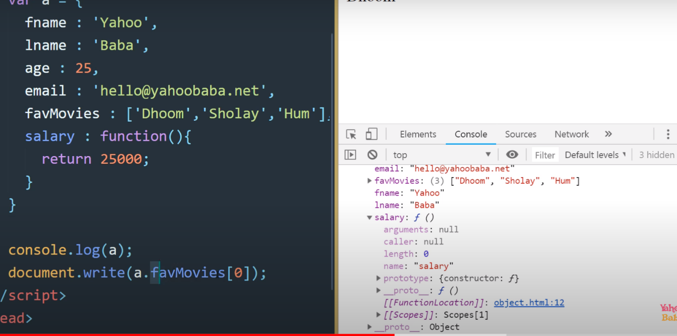

//Is ma first or last name dono ko kasa show krwANA hota ha ///

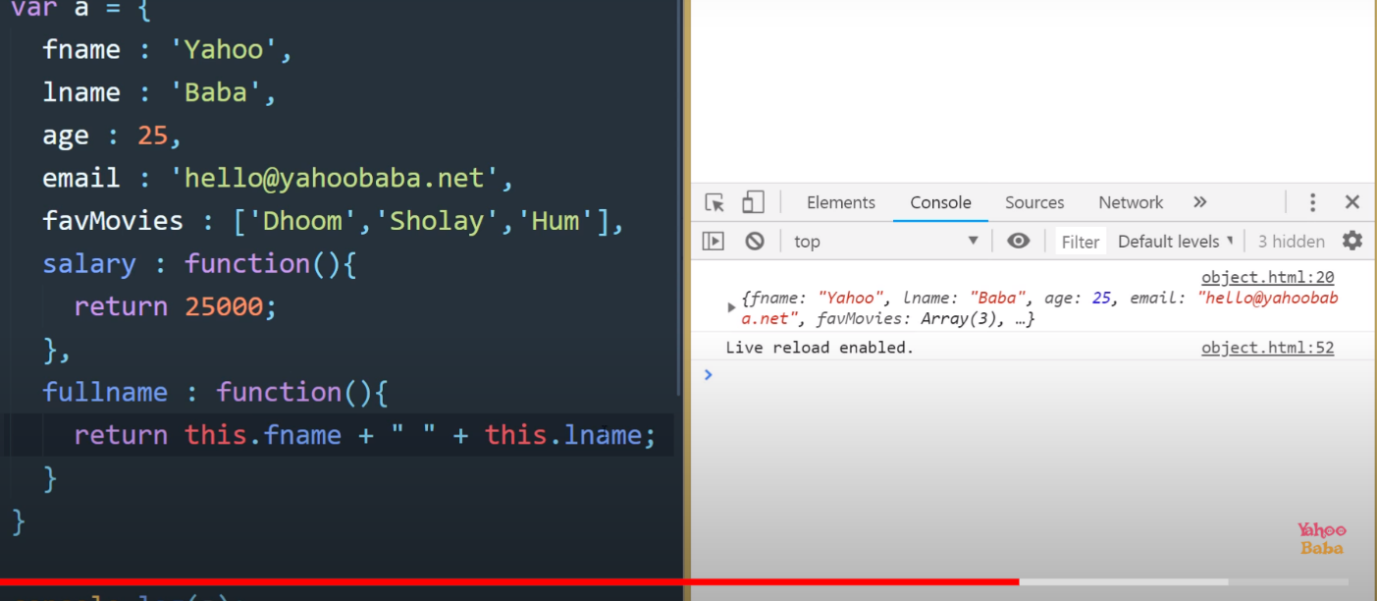

How to add object in objects

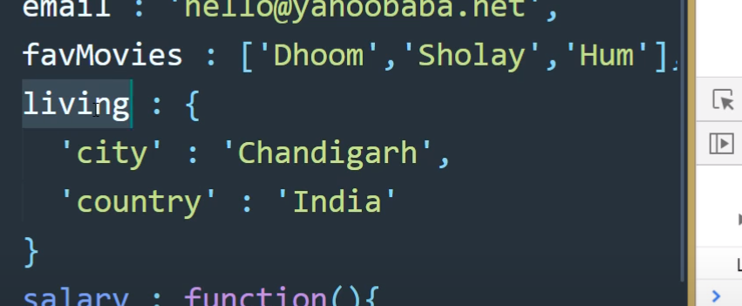

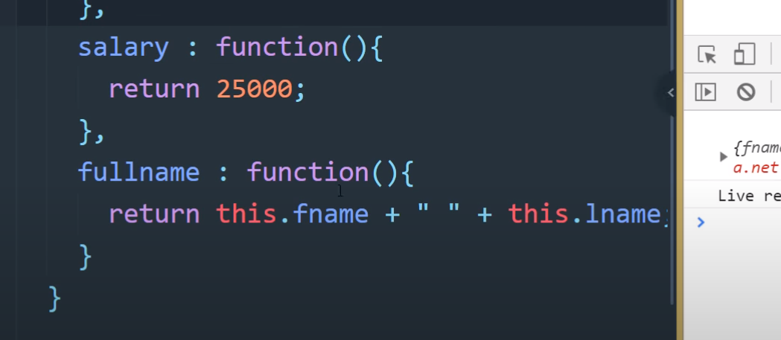

Now we start with hussain sir::

OBJECT IN JAVASCRIPT:

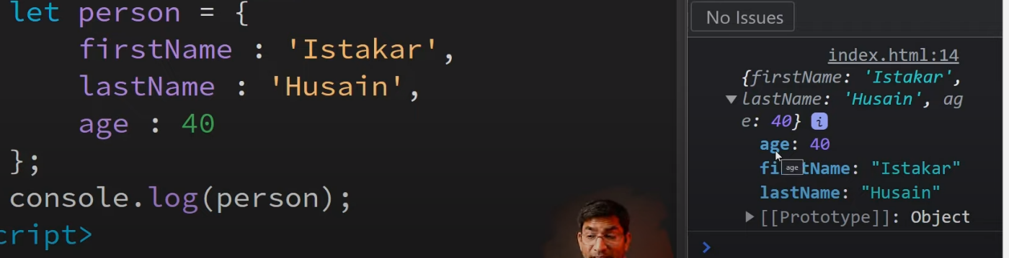OOODF

///AGR hum document.write ma dekha to wo kha ga [object object]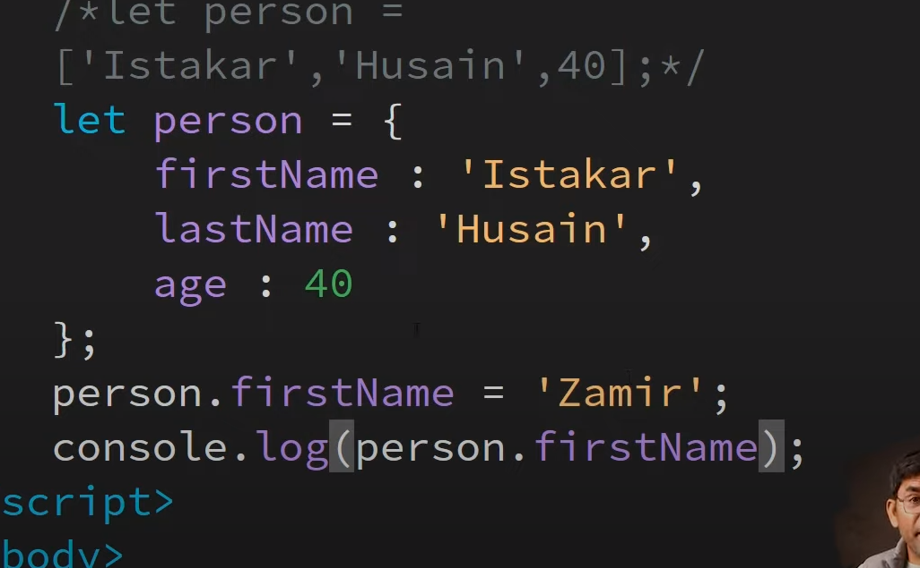

Agr hum na name ma koi change karni ha to

Upr up wala example karni para gi

Math in JAVASCRIPT

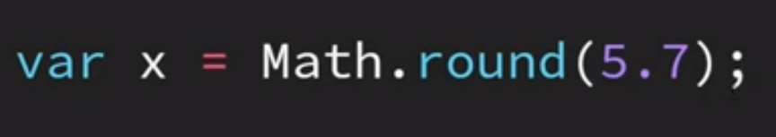

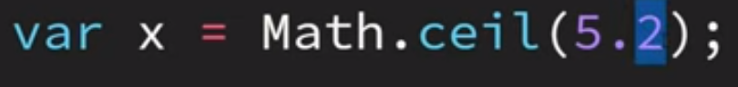

// ceil sa point 5.2 output ma 6 show ho ga

Point ma jo be value ho ge wo zayada btay ga

5.2, 1.2,19.2(6, 2, 20) iss terha value btay ga///

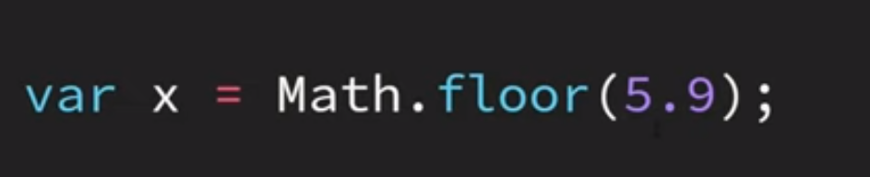

//// floor jitne point ma value ho ge una zero samja ga

Or output 5.9 ka 5 da ga//

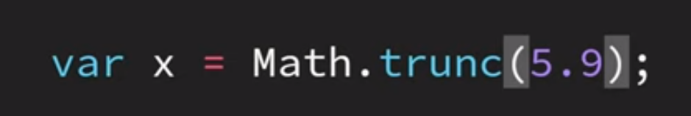

Some work as aa(floor)

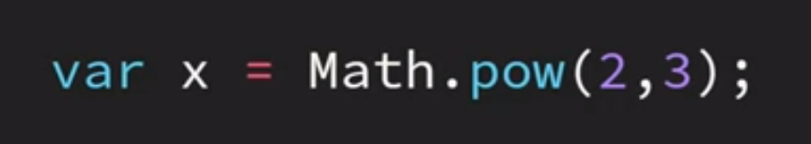

//is ma 2ke power 3 ha output 8anser ho ga

//

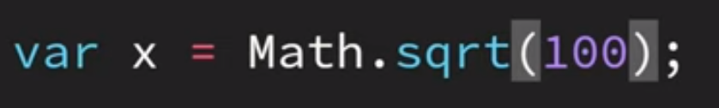  
//ya value ka square root bta deta ha 100 ka 10

9 ka 3 iss terha//

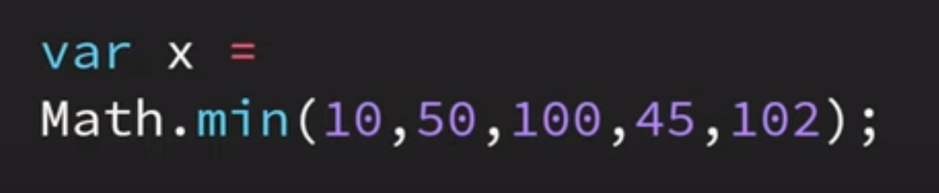

///that tells the minimum value///

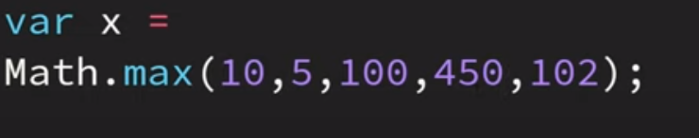

/// that tell maximum value//

DATE METHOD

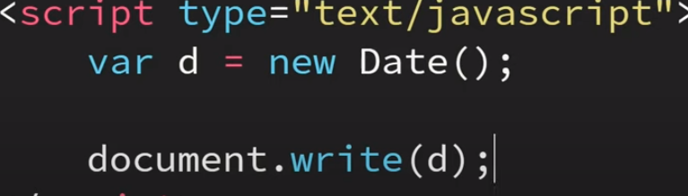

/// is ma date/time live btay ga//

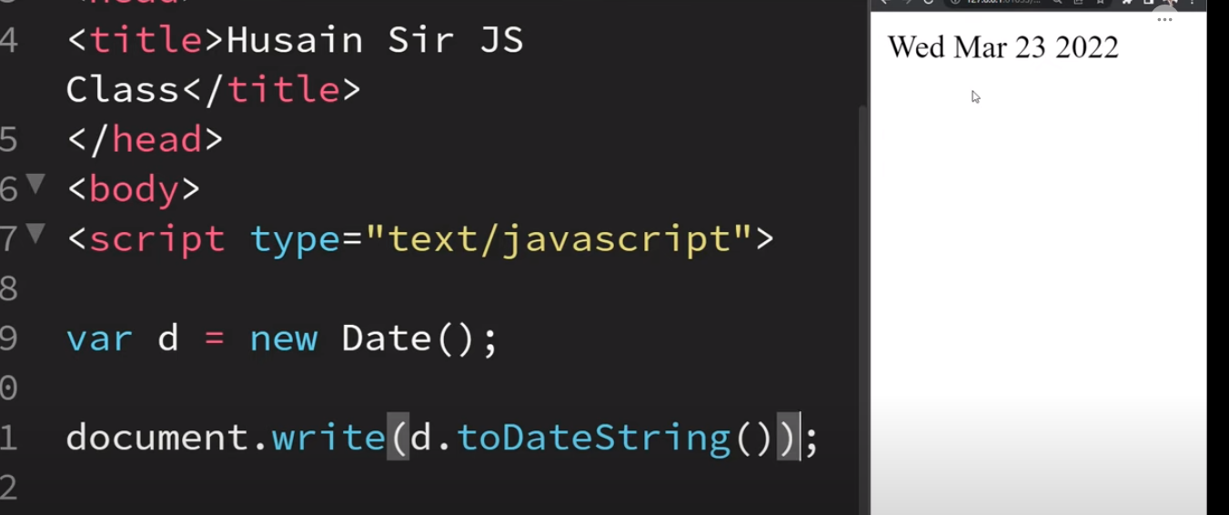

//is ma khali date ay gee//

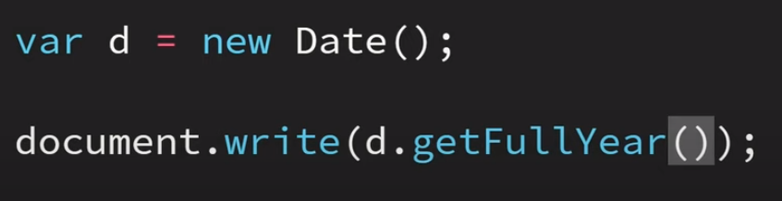

/// for fullyear//

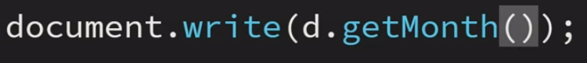

//for month only ya zero sa start karta ha or 11 month btata ha /

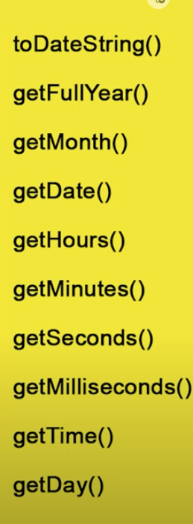

/// apni marze ke date fix karni ho to iss terha karta

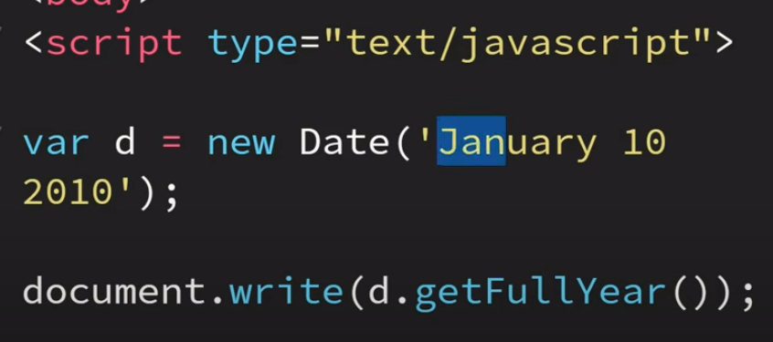

ha///

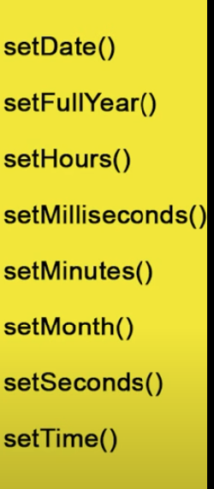

///for set//

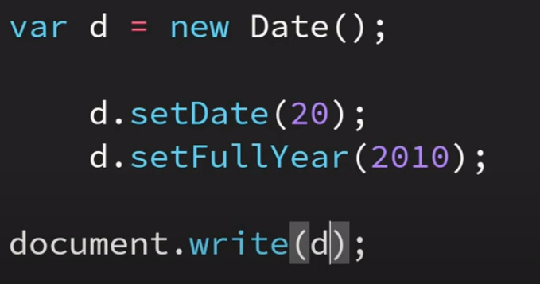

DOM



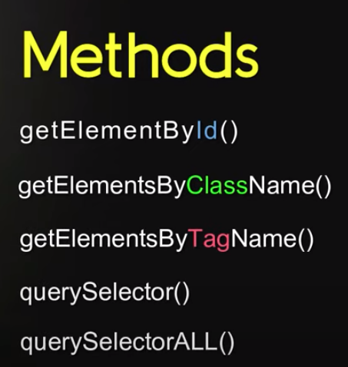

///

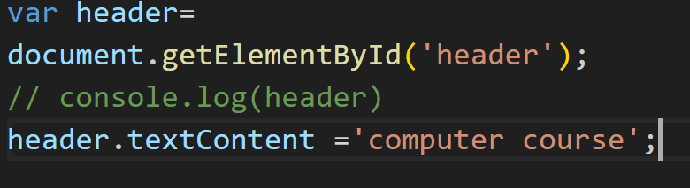//is sa header ma chez change ho gai ha //s

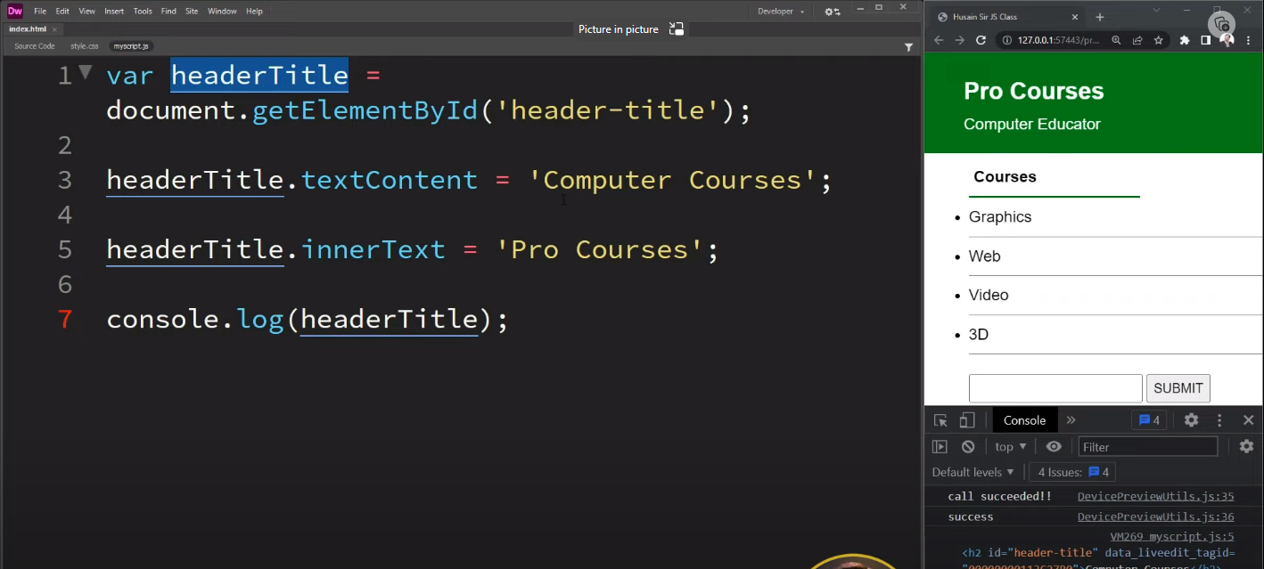  
//// is tarika s ahum kisse be chez ko change kr sakta ha through (id)

//// inner html tag//

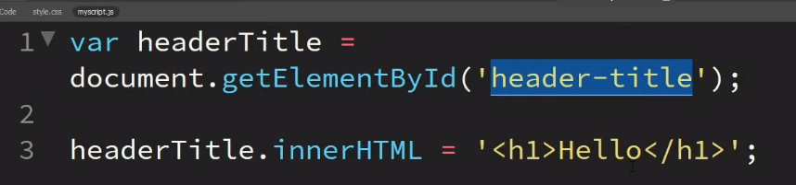

Style javsacript

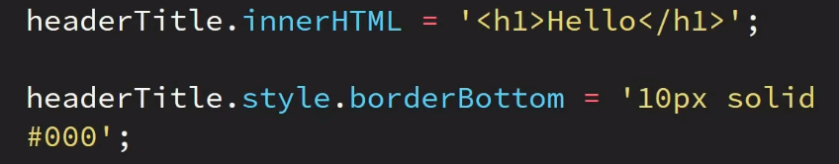

getElementsByclassName ()

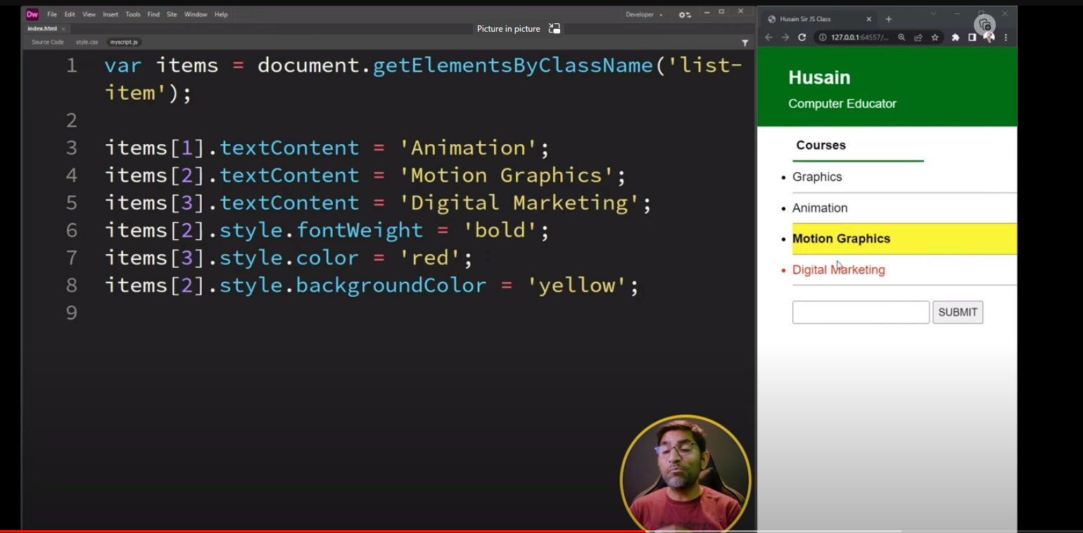

For all background color

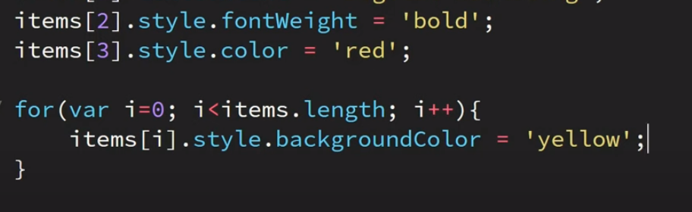

getElementByTagNAme

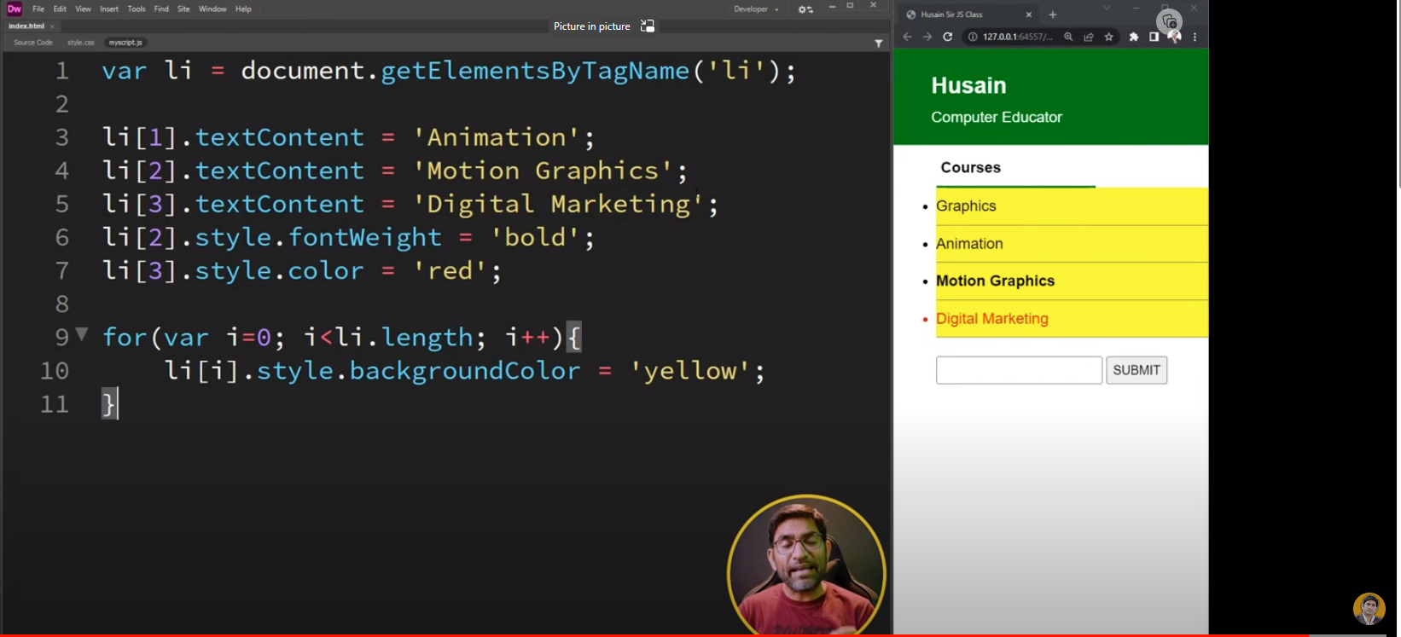

DOM | querySelector and querySelector All Methodes in JavaScript

ya first wala ko select karta ha

<div id="header">

        <h1>This the  heading</h1>

        <p>this is paragraph</p>

    </div>

var header=document.querySelector('#header h1 ');

header .style.color ='yellow';

header.style.backgroundColor='blue';

for query selector ///

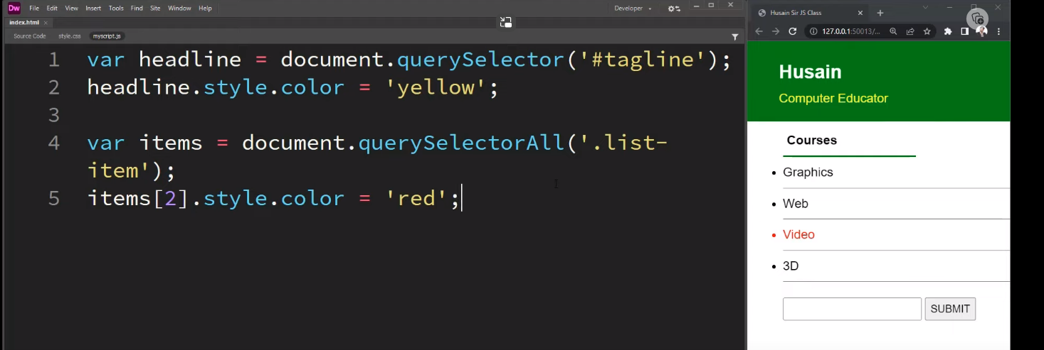

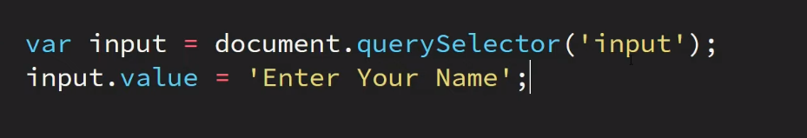

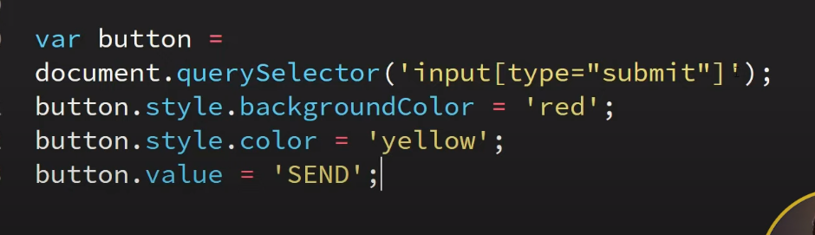

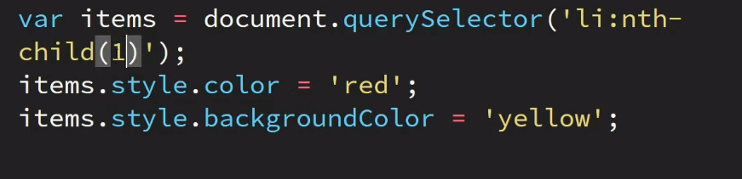

For odd background

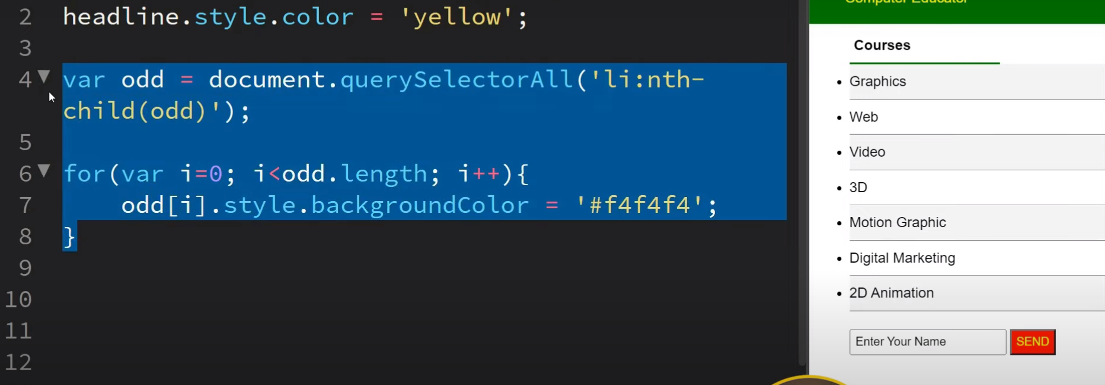

For even number

